Shire of Victoria Plains
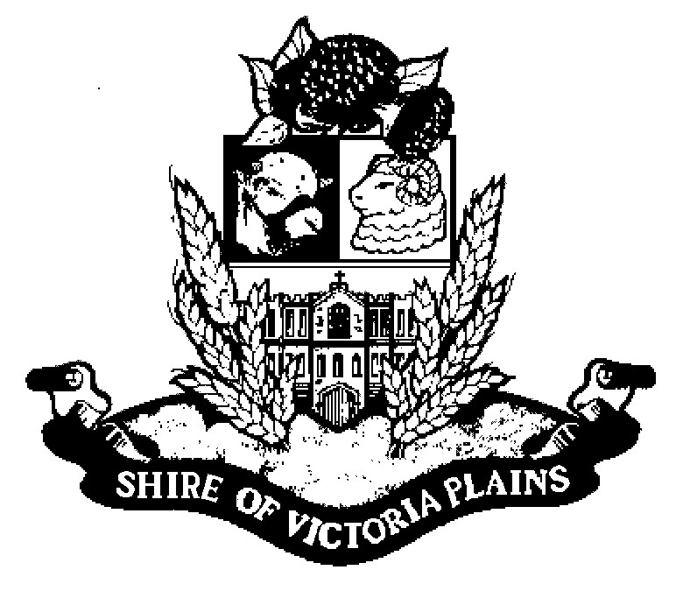
Harvest and Vehicle Movement Bans
Harvest and Vehicle Movement Bans are issued by local governments. DFES provides this information for your general assistance.
It is your responsibility as a harvester operator to be aware of any bans in place before harvesting as you could be fined for breaching a ban.
A Harvest and Vehicle Movement Ban is a ban that individual local governments are responsible for issuing under the Bush Fires Regulations 1954 Section 38A, and/or Section 24C.
Local government will impose the ban when their Bushfire Control Officer is of the opinion that the use of engines, vehicles, plant or machinery during the prohibited burning times or the restricted burning times or both is likely to cause a fire or contribute to the spread of a bushfire
These prohibited and restricted burning times vary between the individual local governments but as a guide generally extend over the traditional summer period from October through to April.
A Harvest and Vehicle Movement Ban may be imposed for any length of time but is generally imposed for the ‘heat of the day’ periods and may be extended or revoked by the local government should weather conditions change.
The responsibility remains on the individual to ensure that any activity undertaken is not likely to start a fire and that a Harvest and Vehicle Movement Ban is currently not in place in their local government area.
To find out if a Harvest and Vehicle Movement Ban has been imposed you need to contact your local government and ask for their Bushfire Control Officer or Ranger Services.

February 2014

