 | Age Friendly Community Plan
 | 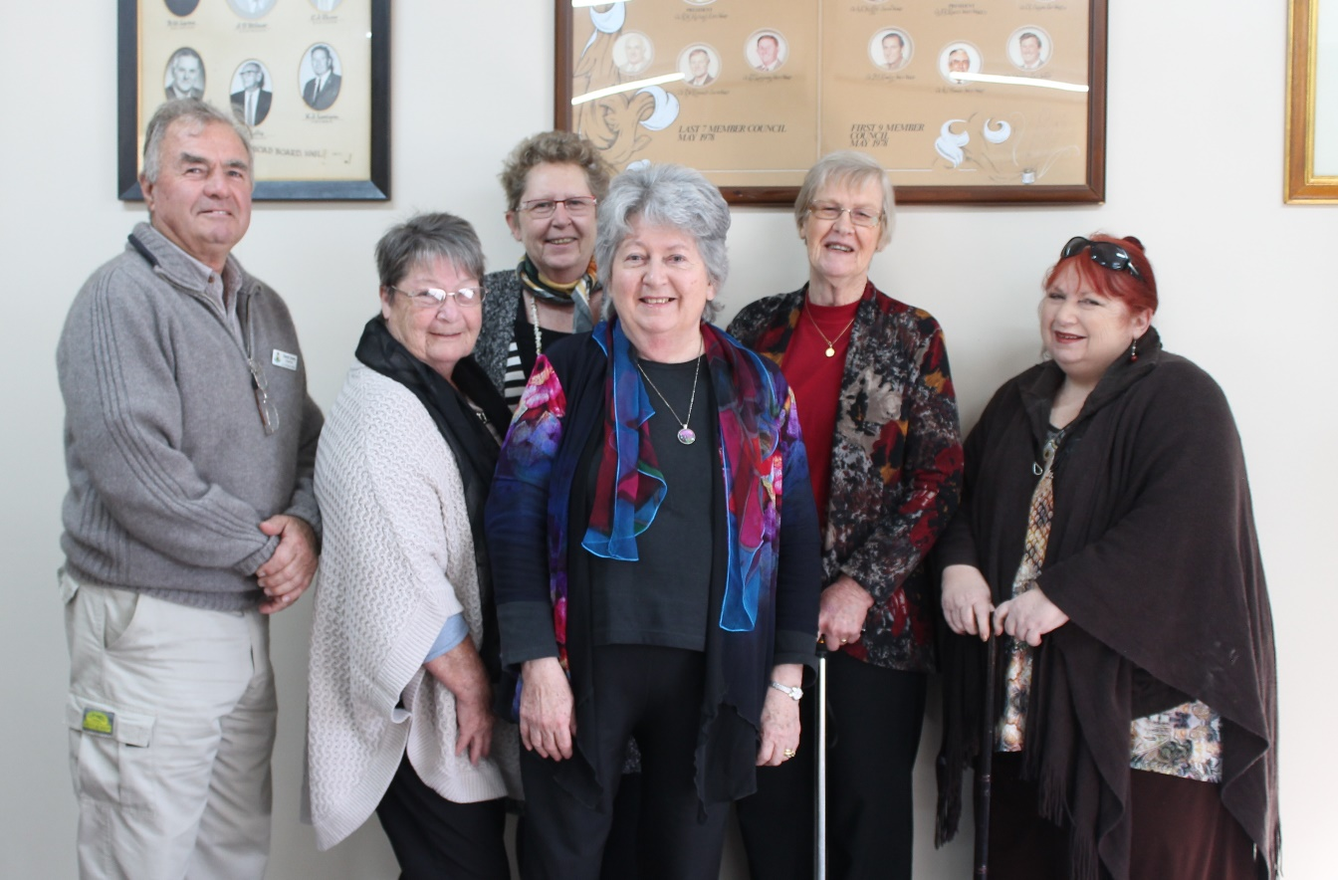
 |  | June 2016 | Final Report

Contents

Message from the President and Chief Executive Officer 1
Key Points of the Plan 2
What is an “Age Friendly Community Plan”? 3
Regional Context 4
Demographic Trends 4
Transport 5
Older Persons Housing 6
Care at Home 6
Residential Care 6
Community Profile 8
How this Plan was Developed 9
Overview 9
Grant Funding 9
Partnership with Chittering 9
Audit 9
Reference Group 10
Consultation 10
Links to Other Plans and Policies 11
Findings 12
Summary of Audit Findings 12
Summary of Engagement Report 13
The Plan 14
Implementation and Monitoring 17
Annex 1: Age Friendly Community Audit Report 18
Annex 2: Engagement Report: Towards an Age Friendly Community Plan 63

Message from the President and Chief Executive Officer
It is our great pleasure to introduce the Shire of Victoria Plain’s Age Friendly Community Plan. This is a vital document to meeting the needs of all residents and community members, both young and old, living in the Shire.
The elderly population in the Shire of Victoria Plains is projected to increase 118.6% or 129 people by 2027. Planning for this increase is crucial and this plan has been created to assess the needs of the Shire of Victoria Plain’s ageing community members. In consultation with a reference group, focus group and community survey, and council we have produced the following action plan for creating an even more age-friendly shire. We are very excited to be sharing this plan with you because it is one of the most effective approaches the council can take towards ensuring a smooth transition for our Shire.
An age friendly community is one which recognises the great diversity among older people, respects their decisions and lifestyle choices, and responds flexibly to ageing-related needs. The Shire is committed to helping the community members continue to live in our many localities. After all, the Shire of Victoria Plains offers “one perfect lifestyle” and “a place to grow” old in.
It is also our pleasure to endorse this Age Friendly Community Plan. Although we will undoubtedly face many challenges in the upcoming several years, we are confident that this framework will provide the needed support and goals for us as a community to work towards as a community.

Cr David Lovelock Mr Harry Hawkins
President, Shire of Victoria Plains Chief Executive Officer, Shire of Victoria Plains

Key Points of the Plan
The engagement activities undertaken as part of the development of this Plan found that those who participated enjoy living in the Shire of Victoria Plains. They value the quality of outdoor spaces within the Shire and the social and recreational opportunities available to them. The critical issues, as identified by the community are:
- Need for health and medical services
- Lack of public and/or community transport services to Perth and other Regional Centres
- Provision of safe and suitable footpaths
- Need for improved communication by the Shire
The Shire of Victoria Plains is committed to developing an Age Friendly Community and this plan identifies a number of actions in response to the findings of the community engagement. The high priority actions identified include:
- Actively seeking opportunities to increase health and home care service provision in the Shire
- Increased provision and ongoing maintenance of roads and footpaths
- Construction of ramps to footpaths at critical intersections
- Advocacy on regional transport issues
- Seeking opportunities to increase aged care accommodation
- Working to increase the number of younger volunteers
- Improved Shire communication to ensure residents and visitors can readily access information
This plan sits under the Shire of Victoria Plains Strategic Community Plan, and the Corporate Business Plan. It will be used as an informing strategy, providing direction and a framework for assessing expenditure proposals in future strategic and corporate planning by Shire of Victoria Plains.

A range of key indicators will be used to monitor the success of the Plan.

Date of Adoption and Review Schedule
The Age Friendly Community Plan was adopted by Council on 15 June 2016.
The Age Friendly Community Plan is a long term plan, looking forward for the next 10 years. However; it is not fixed for ten years – it would be long out of date by then. The Shire intend to review the plan annually as part of normal budgetary processes within Council with community input if and where required.

What is an “Age Friendly Community Plan”?
Age Friendly Communities are those that encourage “active ageing by optimising opportunities for health, participation and security in order to enhance the quality of life as people age” (World Health Organisation) . An Age Friendly Community is one which:
- recognises the great diversity among older people;
- promotes their inclusion and contribution in all areas of community life;
- respects their decisions and lifestyle choices; and
- anticipates and responds to ageing-related needs and preferences.
A community that exhibits these qualities is not only an Age-Friendly Community it tends to better cater for the whole population, where a wider range of abilities and needs are met.
The Shire of Victoria Plains considers age-friendly community planning vital to undertake for the following reasons:
- By 2027, Wheatbelt population over 70 will have increased by 75.3%
- The proportion of people 70+ will have increased from 10.4% in 2011 to 17% in 2027
- The increase projected for Victoria Plains is 118.6% to 129 people 70+ in 2027.
In addition to this, older adults generally prefer to remain in their own home and continue to be part of their community. Older adults feel safe, valued and respected in their own community and local governments have a key role in ensuring this can occur.
The Age Friendly Community Plan has been developed and structured using the Wheatbelt Development Commissions Age Friendly Community Planning Guide (based on the World Health Organisation Guide to Age-Friendly Cities and Communities). The WHO eight domains of an age friendly community have been configured to reflect Wheatbelt perspectives: health and community services; outdoor spaces and buildings; transport and movement; housing; sport and recreation; social participation; respect and social inclusion; and communication and information.
An Age Friendly Community Plan identifies the priorities and actions discovered in the resulting process. It identifies the age friendly barriers and areas for improvements that have been recognised by the community and council. An Age Friendly Community Plan is an Informing Strategy under the Integrated Planning and Reporting (IPR) Framework and needs to be resourced and prioritised in the Shire’s ongoing corporate planning process.

Regional Context
This section on the Avon Regional Organisation of Councils (AROC) sub-region has been extracted from the Wheatbelt Aged Support and Care Solutions (WASCS) Report, with a focus on the following sub-sections.

Demographic Trends
The 70+ population in AROC is increasing at a higher rate than any other sub- region in the Wheatbelt. AROC also has the largest amount of people aged 70 or over in the Wheatbelt. There were 2,100 people aged 70+ in 2011, projected to rise to 4,120 by 2027, an increase of 96.2% or 2,020 people.
The largest increases are projected to occur in Chittering (326 people 70+ in 2011 rising by 191.7% to 951 in 2027), Victoria Plains (59 people 70+ in 2011, rising by 118.6% to 129 in 2027) and Toodyay (428 people 70+ in 2011, rising by 108.4% to 892 in 2027). Northam local government area (LGA) has the largest population of people aged 70+ in the whole of the Wheatbelt. As of the 2011 Census there were 1,087 people aged over 70, and this number is projected to increase to 1,821 by 2027.
Accessibility/Remoteness Index of Australia (ARIA) scores reflect ‘Highly Accessible’ through to ‘Accessible’ areas for localities within the AROC sub-region. Scores range from 1.3029 (Northam Town LGA) to 3.3433 (Dowerin LGA). No LGAs in the sub-region qualify for the viability supplement as these commence at an ARIA score of 3.52 or higher. The AROC sub-region has the highest number of Aboriginal and Torres Strait Islander residents of any in the Wheatbelt. Most Aboriginal and Torres Strait Islander persons live in Northam LGA. 75 of 121 persons aged 50-69 identifying as Aboriginal and Torres Strait Islander in the sub-region live in Northam. Dementia needs are projected to increase rapidly in the AROC sub-region. In 2011 there were an estimated 180 people aged 70+ living with dementia, rising to 252 in 2017, and 386 in 2027.
Insecure tenure numbers for those aged 70+ in AROC sub-region are consistent with WA percentages. Five of six LGAs in AROC sub-region considered relatively disadvantaged according to Socio-Economic Indexes for Areas (SEIFA) 2013 Index. Chittering LGA is the only shire scored above 1,000 meaning it is considered relatively advantaged. The highest percentage of people aged 70+ living on a weekly income of less than $400 reside in the AROC sub-region. This translates to 63.4% of those aged 70+, or 1,331 people throughout the sub-region.

AROC Aged Care Support and Solutions Summary
Age Friendly Communities | Home Support and Care |  |  | Residential Care
 | Home and Community Care (HACC) | Home Care | Respite Care
All shires to start/progress action in line with WA Seniors Planning Framework (SPF) | Research reported areas of lower availability and shortfalls in available service types. Plan to address gaps. | Providers coordinate to ensure wide Wheatbelt coverage. Plan for high demand growth. | Provide coordination to maximise availability and to utilise available funding | Consult with Juniper re expansion plans and/or new provider to establish facility funding

Current AROC Service Levels and Provider Summary
HACC | Home Care | Residential Care | Respite Care | Providers
Good but gaps in some Shires | Good but likely covers residential gap | Major supply shortage against planning ratios | Shortages and lacking key forms of respite care | Mainly not for profit. Scope for major expansion in residential care

AROC Residential beds summary and growth estimate
Currently available | 2011 planning ratio target | 2027 planning ratio target
97 | 185 | 350

Transport
Transport was identified as the standout deficiency restricting people’s mobility and connection as well as access to health care. Addressing this issue at a sub-regional and state level requires a concerted approach. Particular difficulties arise for people living in smaller towns or on farms where there is a lack of organised transport to centres such as Northam. This creates a risk of social isolation.
Difficulties also include access to medical facilities in the Metropolitan area, particularly from Midland to the hospital. Residents of Chittering, Northam and Toodyay do not qualify for the Patient Assistance Transport (PAT) Scheme for medical appointments, adding to the logistical demands of the travel and throwing a financial burden onto family or friends.

Older Persons Housing
All shires in the AROC sub-region, except for Northam, reported waiting lists for available older persons housing (Northam information may have been incomplete). Population projections imply escalating demand, with a near doubling of the sub- regional 70+ population in the next 15 years.
The shire roles will need to be shared with housing organisations and/or supported with new resourcing. State government agencies can play a positive role by working with the sub-region to develop innovative approaches. Varied ownership options need to be examined to meet the range of older people who may be seeking appropriate, well located housing.
Where shires are required to be involved they will be understandably reluctant to assume all the burden of assessing, planning and facilitating the building of required housing. A collaborative approach will be needed, involving local housing organisations, shires, AROC and state government.

Care at Home
Most sub-region shires report good levels of HACC service but Chittering and Victoria Plains show a lower level of HACC availability according to state HACC data. Evidence gathered for this project indicates that there is a variable range of HACC services delivered in different shires. For example, delivered meals are not available in Chittering or Victoria Plains. That shire, along with Dowerin and Chittering, appear to have a smaller available range of HACC services. Goomalling reports the largest available range of HACC services. There is reportedly good current availability of the higher level Home Care packages in most sub-region shires, although some report deficiencies (Dowerin and Victoria Plains).
The generally good availability of Home Care is likely because many of the Wheatbelt’s Home Care providers are based in the sub-region. However, there is a major challenge facing the AROC sub-region. By 2022, the new Home Care planning ratios will have increased dramatically and the projected 70+ population in the AROC is predicted to be 3,319. After applying the new ratios to the higher population, the number of available Home Care packages in the sub-region should rise to 153. There will need to be 100 new Home Care places made available in AROC over the next nine years.
Note that on available evidence the locally based supply of Home Care may be masking the current Residential Care gap (see below), but, in addition, it is suspected that this is also tending to ‘capture’ Home Care places in the sub-region to the detriment of the remaining Wheatbelt. There was also evidence of difficulties in accessing support or care in the home in some of the shires within the sub-region e.g. Dowerin.

Residential Care
Residential Care is available primarily at not for profit facilities in Northam and at the Western Australia Country Health Service (WACHS) Multi-Purpose Service at Goomalling. There are 97 operational/funded beds in the sub-region. This is far short of the numbers that should be available under Commonwealth planning ratios which, on a 2011 population of 2,100, stood at 185 beds under the then ratios.
Looking to the future, predicted 70+ population growth to 4,120 by 2027 yields a planning requirement for around 330 total beds to be available inside 15 years i.e. more than 230 additional beds will likely be needed over current capacity within a relatively short planning timeframe.
Many Residential Care facilities are of fairly old design or built as low care “lodges” and many are not suitable for delivery of modern aged care despite the best efforts of staff.
Likely solutions to future aged care needs in this sub-region will have to involve consideration of the essential role of non-government providers. Investment decisions by providers will be needed soon. The level of potential demand for Residential Care could be regarded as a positive in this context. It gives the opportunity for the existing provider to invest in substantial expansion or alternatively offers the chance for a new provider to establish in the sub-region on an economic scale.

Community Profile
The Shire of Victoria Plains comprises the towns and localities of Bolgart, Calingiri, Gillingarra, Mogumber, New Norcia, Piawaning, Waddington and Yerecoin. It is located approximately 160 kilometres north of Perth and covers an area of 2,569 square kilometres. The Shire has a population of 1000 residents.
Figure 1 below, is indicative of the Shire’s projected age profiles from 2011 to 2026. The graph illustrates a noticeable increase in the age cohorts from 55 to 85 years of age and older. The largest difference is expected to occur in the cohort of 55 to 64 years of age. The number of persons in 2011 was recorded as 100 and this number is expected to rise to 130 in 2026. This accounts for a 30% increase of this age cohort. The amount of 75 to 84 year olds will also see an increase. The recorded number of this age cohort was recorded as 20 in 2011 and is projected to reach 30 in 2026, accounting for a 50% increase in population size. This aging population will place a significant amount of pressure on existing services in the Shire of Victoria Plains unless they are accounted for.
Figure 1: Projected age profiles for the Shire of Victoria Plains from 2011 to 2026.

How this Plan was Developed

Overview
The planning model used in this Plan consists of a four step solution-focused process. It has ultimately produced an Informing Strategy consistent with and complementary to the Shire of Victoria Plains’ Strategic Community Plan. The first step is to gain an understanding of each unique local community. A collaborative process involving service providers and seniors themselves is then used to develop a three to five-year plan. Each stage naturally progressed into the next, with the first three steps providing the essential information for understanding the current and longer term needs and preferences, as the basis for strategic planning and action.

Grant Funding
The Shire of Victoria Plains applied for 2014 – 2015 Age-Friendly Communities Regional Local Government Strategic Planning Grants Program. This program, run by the Department of Local Government and Communities, seeks to “optimise opportunities for health, participation, and security by establishing policies, services and structures that improve the quality of life of community members as they age.” The grant funding itself is to assist local governments in regional Western Australia to collect and analyse given findings in respect of the Age-Friendly Communities Framework. Funding was awarded at up to a rate of $10,000 per project.

Partnership with Chittering
In order to reap the most benefit from the Age-Friendly Communities grants, Shires were encouraged to team up with another, similarly geographically located Shire in order to ensure funding of both projects. As the Shires of Chittering and Victoria Plains are part of the Avon Regional Organisation of Councils and are geographically adjacent, they agreed to collaborate on completing their Age Friendly Community Plans, in order to take advantage of the regional perspective and economies of scale.
The two Shires decided to follow the Wheatbelt Development Commission’s Age Friendly Community Planning Guide. They have a strong shared commitment to becoming age friendly communities and a common view of how the planning will benefit their communities, the approach, project outcomes and how the objectives will be met.

Audit
The Shire of Victoria Plains undertook an Age Friendly Community Planning Audit in February 2015 and then again in November 2015. This audit was designed to capture information for the purposes of identifying whether the community is an Age Friendly Community across eight “domains” that are particularly relevant to the wellbeing of seniors. Each domain contains a number of components, sometimes divided into sub-domains. This information enables the Shire and the community to assess where improvements are needed and assist in informing the wider age friendly community planning that will guide future activities and investments. The Report was prepared using the Wheatbelt Development Commission’s Age Friendly Community Planning Audit Tool.

Reference Group
As part of the conditions of fulfilment for the grant, the Shire of Victoria Plains established a reference group that guided and supported the project, liaised with the Department of Local Government and Communities and reviewed the draft reports.

Consultation
The Shire conducted both focus groups and a survey in order to consult with community members. The Shire of Victoria Plains’ focus groups were aimed at both seniors and service providers. They were structured around the eight WHO AFC domains with participants involved in assessing these features in their own communities. A survey was developed and posed a standard set of questions structured around the eight WHO domains. It was promoted to persons within the Shire of Victoria Plains in both electronic and hardcopy forms.
In addition to this, the council was consulted through an issues and options workshop. They were given the results of the community engagement and prioritised various community member concerns that were then used to inform the creation of this Plan.

Links to Other Plans and Policies

Strategic Community Plan
The Shire of Victoria Plains Strategic Community Plan (2013/14) describes the community priorities for the ten year period from 2013/14 – 2022/23 and the key activities the Shire will focus on to achieve the community aspirations. The Strategic Community Plan presents four goals including “Community - Increase the sustainability of the community”. One of the strategies under this goal states they will develop a ‘Health Services Plan’ that identifies ways to increase the number of health professionals to support the area and provide more aged housing/accommodation.

Corporate Business Plan
The Shire of Victoria Plains Corporate Business Plan (2013/14) translates the community aspirations outlined in the Strategic Community Plan into an implementable work program. The Corporate Business Plan identifies several aspects related to ensuring an age friendly community with a particular focus on health care and accommodation.
Disability Access and Inclusion Plan (DAIP) 2015 – 2020
The Disability Access and Inclusion Plan (DAIP) is required under The Disability Services Act 1993 with the aim of planning and implementing improvements across seven outcome areas. These plans benefit people with disability, older people, young parents and people from culturally and linguistically diverse backgrounds. The Shire of Victoria Plains DAIP identifies a range of access improvement opportunities that will have a particular benefit to older people in the community. Some of these actions are very closely related or a duplicate of the priority actions identified within this Plan. This correlation reinforces the importance of this Plan and the broader community outcomes beyond older people.

Findings

Summary of Audit Findings
Contained below is a summary of the extensive findings compiled in an Audit report. The complete Audit can be found in Annex 1.
Health and community services
- There is not a GP or health centre located within the Shire of Victoria Plains
- Wongan Hills and Goomalling Hospitals were within 60 minutes of Calingiri and Bolgart. Moora Hospital is within 60 minutes of Yerecoin.
- There are dental services located within 60 minutes of the town in Moora, Bindoon and Goomalling but there are no dental services located within the Shire.
- There is a lack of ambulance volunteers.
- There are no allied health services or pharmacies within the Shire.
- The Health and Community Care Services provided include:
  - domestic assistance, including helping with cleaning, washing and shopping; and
  - social support including social outings.
Outdoor spaces
- Several open spaces were surveyed for the audit. Specific results for these parks and outdoor spaces can be found in the report.
- Parks generally have disability access and are adequately wide enough for at least one wheelchair, gopher or walking frame.
Public buildings
- Public buildings surveyed include administration buildings, a town hall and library and other public buildings of note. Full details and results for these buildings can be found in the full report.
- Buildings were generally accessible with non-slip floors.
Transport and movement
- The newer footpaths in the Shire are built to a high standard. There are older footpaths that are narrow and adequate for one wheelchair, gopher or walking frame. Footpaths are generally well maintained and free of obstructions.
- Traffic signs are generally well placed and visible.
- There is no community transport available in the Shire of Victoria Plains. Other community transport is available in the form of friends, family and neighbours only. Arrangements can be made with the Shire of Chittering and Shire of Wongan for use of their community bus.
Housing
- There is not sufficient suitable housing for meet the needs of the ageing population in the future.
Information regarding the following areas is available in the Engagement Report, found in Annex 2:
- Sport and recreation
- Social participation
- Respect and social inclusion
- Communication and information

Summary of Engagement Report
It is clear from the results of the engagement activities that both survey respondents and focus group participants enjoy living in the Shire of Victoria Plains. However, the research also shows that the community feel that there are some opportunities for improvement regarding the provision of key services in order to create an age friendly community. The full Engagement Report can be found in Annex 2.
The key findings are:
- A total of 12 individuals participated in the focus group (seven seniors and five service providers) and 19 individuals participated in the surveys.
- Of those seniors who participated, 100% of survey respondents and 79% of focus group participants are retired.
- The majority of both survey and focus group respondents believe that improved provision of health and community services and maintenance of footpaths and roads will lead to a more fulfilling experience for seniors in the Shire of Victoria Plains.
- Focus group participants believe the most important issues for aged persons in the Shire of Victoria Plains are:
  - Increased access to full health and community services
  - Increased communication with seniors regarding services the Shire provides
  - Maintenance of footpaths and roads
- Survey respondents believe the most important issues for aged persons in the Shire of Victoria Plains are:
- Increased provision of medical services
- Provision of a district nurse or equivalent
- Access to medical services for those who are unable to drive
- Communication by the Shire.

The Plan
The Plan is based on the eight domains of an age friendly community (two of which have been combined based on community feedback), each with a number of associated actions as listed in the following table. These are designed to allow Council to respond to changing needs and ensure support for the wellbeing of the Shire of Victoria Plains ageing population. Many of the actions outlined are able to be implemented within existing resources however any new or expanded activity will be considered through the Shires standard corporate planning processes.
Health and Community Services
Objective | Actions | Priority | Within existing resources? | Others involved
Ensure older people have access to quality and reliable health and community services allowing them to age in place and keep travel to a minimum. | Actively seek opportunities to increase the availability of medical services in the Shire | High | Yes | WA Country Health
 | Facilitate and advocate for support services for seniors in their own home | High | Yes | Silverchain  Aged Care Service Providers

Outdoor Spaces and Buildings
Objective | Actions | Priority | Within existing resources? | Others involved
Create outdoor spaces and movement networks that promote mobility, independence and quality of life for older people. | Well planned maintenance of roads and footpaths | High | Yes
 | Increased provision of footpaths | High | No
 | Increased provision of street lights across the Shire | Medium | No | Western Power
 | Increased seating on main walking routes | Medium | Yes
 | Gently sloping ramps to footpaths at key intersections | High | Yes

Transport and Movement
Objective | Actions | Priority | Within existing resources? | Others involved
Ensure seniors have access to safe and consistent transport options. | Investigate and actively seek opportunities to acquire a community bus | Medium | Yes | Funding Providers
 | Advocacy on regional transport solutions | High | Yes | Neighbouring Shires  Wheatbelt Development Commission

Housing
Objective | Actions | Priority | Within existing resources? | Others involved
Investigate and advocate for accessible, affordable and diverse housing options that contribute to the ability of people to stay in their community. | Seek opportunities to increase provision of aged care accommodation | High | Yes | AROC  State Government  Federal Government  Age Care Providers

Sport and Recreation
Objective | Actions | Priority | Within existing resources? | Others involved
Provide facilities and recreation services that contribute to the social and physical wellbeing of older community members. | Better use of existing facilities | Medium | Yes | Community Organisations
 | Facilitate effective succession planning for volunteers | Medium | Yes | Volunteering WA  Community Groups/ Organisations

Social Participation/Respect and Social Inclusion
Objective | Actions | Priority | Within existing resources? | Others involved
Facilitate opportunities for community members to engage with each other through volunteering and events. | Facilitate and actively seek opportunities to increase the number of young volunteers with a particular focus on Calingiri. | High | Yes | Volunteering WA  Community Groups/ Organisations
 | Increase and promote community involvement with Council decision making (i.e. Maintenance priorities) | Medium | Yes | Community Groups / Organisations

Communication and Information
Objective | Actions | Priority | Within existing resources? | Others involved
Ensure high quality, reliable and up to date information is made available to older people in the community. | Improved Shire communication | High | Yes | Regional newspapers  ABC radio
 | Access to information for residents and tourists | High | Yes
 | Facilitate improve communication between agencies providing services in the Shire. | Medium | Yes

Implementation and Monitoring
Implementation of this plan will occur through ongoing corporate planning. Resourcing of any new or expanded initiatives will need to be considered through the due process of the Shire’s Integrated Planning and Reporting.
This Age Friendly Community Plan reflects the Shire’s strong commitment to optimising opportunities for health, participation and security for ageing community members. This commitment is aligned to the Western Australia State Government an Age Friendly WA: The Seniors Strategic Planning Framework. The Shire is not the only agency with responsibility for ensuring an age friendly community and the exact contribution it makes is difficult to measure. Indicators outlines below will rely on consultation with community, relevant stakeholders and service providers. A large number of other factors influence how the ageing population experience community life across the eight domains of an Age Friendly Community. However, the Shire will monitor a set of key indicators as outlined below to track the progress of the sector in terms of the overall goal of the Plan.
Indicators
Health and Community Services
- Community satisfaction with availability and access to health and medical services
Outdoor Spaces and Buildings
- Community satisfaction with footpaths
- Community satisfaction with the provision of seating and lighting across the Shire
Transport and Movement
- Acquisition of a community bus
Housing
- Increase in the provision of aged care accommodation
Sport and Recreation
- Community satisfaction with Shire facilities
- Succession plans developed with volunteer groups
Social Participation/Respect and Social Inclusion
- Consistent or growing number of younger volunteers
- Increased community involvement with Council decision making processes
Communication and Information
- Community satisfaction with the provision of Shire information

Annex 1: Age Friendly Community Audit Report

Shire of Victoria Plains
Age Friendly Community Audit
Version 2.0

Audit Title
Shire of Victoria Plains Age Friendly Community Audit

Conducted on
6/02/2015 1:53 pm
17/11/2015 1:05 pm

Prepared by
Localise

Personnel
Mark Dacombe, Director, Localise
Jen Perry, Project Officer, Localise
Harry Hawkins, Chief Executive Officer, Shire of Victoria Plains

Table of Contents

INTRODUCTION 22
HEALTH AND COMMUNITY SERVICES 22
GP/Health Centre 22
Hospital 22
Dental 22
Allied health services 23
Pharmacy 23
Shopping 23
Health and Community Care Services (HACC) 23
PUBLIC SPACES AND PARKS 24
Progress Park 24
Federation Memorial Park 25
Bolgart Memorial Park 25
PUBLIC BUILDINGS 27
Administration Building 27
Road Board Building – Five Roads Cafe 28
Calingiri Traders 29
Recreation Hall 30
Bolgart Hall and Library 31
Yerecoin Traders 33
Yerecoin Hall 34
Mogumber Library and Post Office 35
Mogumber Hall 36
TRANSPORT AND MOVEMENT 37
Pedestrian Movement 37
Road Signage 38
Public and Community Transport 38
HOUSING 39
Housing Stock 39
Maintenance and adaptation services 39
Retirement Village/Seniors Housing 39
SPORT AND RECREATION 40
Facilities 40
Clubs 40
SOCIAL PARTICIPATION 40
Volunteering 40
Community events and activities 40
RESPECT AND SOCIAL INCLUSION 40
Respect and Social Inclusion 40
COMMUNICATION AND INFORMATION 41
Communication and Information 41
PHOTOGRAPHS 42

INTRODUCTION
Introduction
The Age Friendly Community Audit Report is designed to capture information for the purposes of identifying whether the community is an Age Friendly Community across eight “domains” that are particularly relevant to the wellbeing of seniors. Each domain contains a number of components, sometimes divided into sub-domains.

This information enables the Shire and the community to assess where improvements are needed and assist in informing the wider age friendly community planning that will guide future activities and investments.

The Report has been prepared using the Wheatbelt Development Commission’s Age Friendly Community Planning Audit Tool.

Document History
- Version 2.0 is a comprehensive version of the document. All effort has been made to fill existing gaps left in Version 1.0. Completed 17/11/2015 1:05 pm by Jen Perry.
- Version 1.0 is a preliminary version, focusing on the physical site audit, existing knowledge and seniors’ feedback where available to robustly identify small improvement projects that can make a difference to seniors’ wellbeing in the short term. A shortlist of suitable projects will be prioritised through the Wheatbelt Development Commission’s prioritisation tool, and the highest ranking projects will be submitted for grant funding. Completed 6/02/2015 1:53 pm by Mark Dacombe and Harry Hawkins.

HEALTH AND COMMUNITY SERVICES
Question |  | Response | Details

GP/Health Centre
Is there a GP service in your community? |  | No

Hospital
Is there a hospital within 60 minutes from the town? |  | Yes | Wongan Hills and Goomalling Hospitals within 60 minutes from Calingiri and Bolgart.  Moora Hospital within 60 minutes from Yerecoin
Does the hospital have an Emergency service? |  | Yes | All 3 Hospitals have Emergency service
Is the hospital in your local government area? |  | No

Dental
Is there a dental service within 60 minutes from the town? |  | Yes | Moora  Bindoon  Goomalling
Is the dental service in your local government area? |  | No

Allied health services
Are there allied health services (physiotherapy, occupational therapy, podiatry, physiologist, dietitian etc.) within 60 minutes from the town or visiting services available? |  | No

Pharmacy
Is there a pharmacy? |  | No

Shopping
Is there a shopping complex or precinct? |  | Yes | Bolgart shop
Appendix 1

Insert address of shopping complex or precinct. |  | Bolgart
Appendix 2

Is there disability access into the shops? |  | No | Small ramps required (see Appendix 3)
Appendix 3 | Appendix 4 | Appendix 5 | Appendix 6

Is disability parking available? |  | No
Is the shopping complex or precinct accessible by public or community transport? |  | No

Health and Community Care Services (HACC)
Is a Home and Community Care (HACC) service provided? |  | Yes
Which HACC services are provided? |  | Domestic assistance, including helping with cleaning, washing.
Is the service promoted in the community? |  | 1 – Not at all
Are seniors satisfied with the provision of HACC services? |  | See Engagement Report: Towards an Age Friendly Community Plan (2015)

PUBLIC SPACES AND PARKS
Question | Response | Details

Progress Park
Address | Yulgering Road, Calingiri
Appendix 7

Is there disability access? | Yes | Pathway  Child proof gate may be a barrier
Appendix 8

Is disability parking available? | No
Is the park accessible by public or community transport? | No
Is the park well shaded? | Yes | Large trees, which are a problem with debris
Appendix 9 | Appendix 10

Are there well scattered benches or seating? | Yes
Appendix 11

Is the park well lit? | Yes | Under gazebo and spot on hall
Appendix 12

Are there footpaths within the park? | Yes
Is the footpath wide enough for wheelchairs/gophers/walking frames? | Adequate for one wheelchair/gopher (1.0m - 1.49m)
Are pedestrian and cycle access separated? | No
Are footpaths well maintained and free of obstructions? | Yes

Federation Memorial Park
Address | Yulgering Road, Calingiri
Appendix 13

Is there disability access? | Yes
Appendix 14

Is disability parking available? | No
Is the park accessible by public or community transport? | No
Is the park well shaded? | No
Appendix 15

Are there well scattered benches or seating? | Yes
Appendix 16 | Appendix 17 | Appendix 18

Is the park well lit? | No | Spots on obelisk
Are there footpaths within the park? | Yes
Is the footpath wide enough for wheelchairs/gophers/walking frames? | Adequate for two wheelchairs/gophers (1.5m or above)
Are pedestrian and cycle access separated? | No
Are footpaths well maintained and free of obstructions? | Yes

Bolgart Memorial Park
Address | Bolgart
Appendix 19 | Appendix 20

Is there disability access? | Yes | Behind hall, disabled toilet alongside park
Appendix 21

Is disability parking available? | No | Can drive right to hard area
Appendix 22

Is the park accessible by public or community transport? | No
Is the park well shaded? | Yes
Appendix 23 | Appendix 24

Are there well scattered benches or seating? | Yes
Appendix 25 | Appendix 26 | Appendix 27

Is the park well lit? | No | Light on BBQ
Appendix 28

Are there footpaths within the park? | Yes
Appendix 29

Is the footpath wide enough for wheelchairs/gophers/walking frames? | Adequate for two wheelchairs/gophers (1.5m or above)
Are pedestrian and cycle access separated? | No
Are footpaths well maintained and free of obstructions? | Yes

PUBLIC BUILDINGS
Question | Response | Details

Administration Building
Address | 28 Cavell Street, Calingiri
Appendix 30

Is there clearly visible directional and identification signage? | Yes
Appendix 31

Is there clearly visible navigational signage within the building? | Yes | Small reception area opening into library. Good signage.
Is there disability access into the building? | Yes | Self-opening door  Council chambers separate
Appendix 32 | Appendix 33 | Appendix 34 | Appendix 35

Is disability parking available? | No | Front area being redesigned to include
Is the building accessible by public or community transport? | No
Is the front counter/reception desk no higher than 870mm with 800mm knee and toe plate clearances? | No | 1120mm
Appendix 36

Is it easy to get around the public areas of the building? (This may include lift access, ramps, wheelchair access doors etc.) | Yes
Appendix 37 | Appendix 38

Are the floors non-slip? | Yes | Carpet
Appendix 39

Are there unisex disability accessible toilets? | Yes | Nearest in the Caravan Park
Appendix 40

Road Board Building – Five Roads Cafe
Address | 19 Cavell St, Calingiri
Appendix 41

Is there clearly visible directional and identification signage? | Yes
Is there clearly visible navigational signage within the building? | N/A
Is there disability access into the building? | Yes | 1000 mm double door  Counter to door very close  Ramp at rear
Appendix 42 | Appendix 43 | Appendix 44 | Appendix 45

Is disability parking available? | No
Is the building accessible by public or community transport? | No
Is the front counter/reception desk no higher than 870mm with 800mm knee and toe plate clearances? | No | 940mm
Appendix 46

Is it easy to get around the public areas of the building? (This may include lift access, ramps, wheelchair access doors etc.) | Yes
Are the floors non-slip? | Yes | Wood smooth
Appendix 47

Are there unisex disability accessible toilets? | Yes | Camping ground next door  Also at back of the building
Appendix 48

Calingiri Traders
Address | 17 Cavell St, Calingiri
Appendix 49

Is there clearly visible directional and identification signage? | Yes
Is there clearly visible navigational signage within the building? | N/A
Is there disability access into the building? | Yes
Appendix 50

Is disability parking available? | No
Is the building accessible by public or community transport? | No
Is the front counter/reception desk no higher than 870mm with 800mm knee and toe plate clearances? | No | 1000mm no toes
Is it easy to get around the public areas of the building? (This may include lift access, ramps, wheelchair access doors etc.) | Yes
Appendix 51 | Appendix 52 | Appendix 53 | Appendix 54

Are the floors non-slip? | Yes
Appendix 55

Are there unisex disability accessible toilets? | No

Recreation Hall
Address | Yulgering Road, Calingiri
Appendix 56 | Appendix 57

Is there clearly visible directional and identification signage? | Yes
Is there clearly visible navigational signage within the building? | Yes
Is there disability access into the building? | Yes | Level off footpath through double door
Appendix 58 | Appendix 59 | Appendix 60 | Appendix 61 | Appendix 62

Is disability parking available? | No
Is the building accessible by public or community transport? | No
Appendix 63

Is the front counter/reception desk no higher than 870mm with 800mm knee and toe plate clearances? | No
Is it easy to get around the public areas of the building? (This may include lift access, ramps, wheelchair access doors etc.) | Yes
Appendix 64 | Appendix 65

Are the floors non-slip? | Yes
Are there unisex disability accessible toilets? | No

Bolgart Hall and Library
Address | George Street, Bolgart
Appendix 66 | Appendix 67 | Appendix 68

Is there clearly visible directional and identification signage? | Yes
Is there clearly visible navigational signage within the building? | Yes | Basic EXIT signage
Is there disability access into the building? | Yes | Into CWA room only otherwise onto the stage
Appendix 69

Is disability parking available? | No
Is the building accessible by public or community transport? | No
Is the front counter/reception desk no higher than 870mm with 800mm knee and toe plate clearances? | N/A
Is it easy to get around the public areas of the building? (This may include lift access, ramps, wheelchair access doors etc.) | No | Library doorway 750mm  Access to stage by steps
Appendix 70 | Appendix 71 | Appendix 72 | Appendix 73

Are the floors non-slip? | Yes | Smooth wood
Appendix 74

Are there unisex disability accessible toilets? | Yes
Appendix 75

Yerecoin Traders
Address | 38 Miling Rd, Yerecoin
Appendix 76

Is there clearly visible directional and identification signage? | Yes
Is there clearly visible navigational signage within the building? | Yes | See photos
Is there disability access into the building? | No | Wide door low lip
Appendix 77

Is disability parking available? | No
Is the building accessible by public or community transport? | No
Is the front counter/reception desk no higher than 870mm with 800mm knee and toe plate clearances? | Yes | 920
Is it easy to get around the public areas of the building? (This may include lift access, ramps, wheelchair access doors etc.) | Yes
Appendix 78 | Appendix 79 | Appendix 80

Are the floors non-slip? | Yes | Lino
Appendix 81

Are there unisex disability accessible toilets? | No

Yerecoin Hall
Address | Miling Road, Yerecoin
Appendix 82 | Appendix 83

Is there clearly visible directional and identification signage? | Yes
Is there clearly visible navigational signage within the building? | Yes | Basic EXIT signs
Is there disability access into the building? | Yes | Level off gravel
Appendix 84

Is disability parking available? | No | Large gravel car park  1.8 m footpath through town
Appendix 85 | Appendix 86

Is the building accessible by public or community transport? | No
Is the front counter/reception desk no higher than 870mm with 800mm knee and toe plate clearances? | N/A
Is it easy to get around the public areas of the building? (This may include lift access, ramps, wheelchair access doors etc.) | Yes
Appendix 87 | Appendix 88

Are the floors non-slip? | Yes | Wood
Appendix 89

Are there unisex disability accessible toilets? | TBA

Mogumber Library and Post Office
Address | Mogumber Yarawindah Road, Mogumber
Appendix 90

Is there clearly visible directional and identification signage? | Yes
Is there clearly visible navigational signage within the building? | N/A
Is there disability access into the building? | Yes | But there is a small lip at door
Appendix 91 | Appendix 92

Is disability parking available? | No | Plenty of general parking
Appendix 93

Is the building accessible by public or community transport? | No
Is the front counter/reception desk no higher than 870mm with 800mm knee and toe plate clearances? | Yes | Issue desk 740mm
Appendix 94

Is it easy to get around the public areas of the building? (This may include lift access, ramps, wheelchair access doors etc.) | Yes
Appendix 95 | Appendix 96

Are the floors non-slip? | Yes
Appendix 97 | Appendix 98

Are there unisex disability accessible toilets? | Yes
Appendix 99

Mogumber Hall
Address | Bindoon Moora Road, Mogumber
Appendix 100 | Appendix 101 | Appendix 102 | Appendix 103 | Appendix 104

Is there clearly visible directional and identification signage? | Yes
Is there clearly visible navigational signage within the building? | N/A
Is there disability access into the building? | Yes
Appendix 105 | Appendix 106 | Appendix 107

Is disability parking available? | No
Is the building accessible by public or community transport? | No
Is the front counter/reception desk no higher than 870mm with 800mm knee and toe plate clearances? | No | Servery 900mm
Appendix 108

Is it easy to get around the public areas of the building? (This may include lift access, ramps, wheelchair access doors etc.) | Yes | But disability access is through the front door and the toilets are at the rear over uneven terrain.
Appendix 109 | Appendix 110

Are the floors non-slip? | Yes | Lino and carpet  Wooden in main Hall
Appendix 111 | Appendix 112

Are there unisex disability accessible toilets? | No | Old and substandard. No disability toilet need to be replaced in the next couple years.

TRANSPORT AND MOVEMENT
Question | Response | Details

Pedestrian Movement
Are the footpaths wide enough for wheelchairs/gophers/walking frames generally? | The newer footpaths are built to a high standard. There are older foot paths that are narrow and adequate for one wheelchair/gopher (1.0m - 1.49m) only, in particular the footpaths in Edmonds Street and Yulgering Road.
Are pedestrian and cycle access separated generally? | No
Are footpaths well maintained and free of obstructions generally? | Yes
Are footpaths well lit generally? | Yes | Lighting on every second pole
Is there adequate seating along major pedestrian routes? | No | No seating
Are there adequate footpaths provided on key access routes generally (e.g. Residential to facilities etc.) | Yes | Note Cavell St footpaths quite narrow at 1.2m
Appendix 113

Are there any footpaths that require attention? | Yes | People provide intelligence from time to time that is acted on
Are pedestrian crossings adequately provided generally? | Yes | No formal “zebra” pedestrian crossings but crossing points are provided
Are there pedestrian crossings on key access routes? (e.g. To community services and public facilities) | Yes
Are there accessible, sloping curbs at pedestrian crossings? | Yes | Every intersection has been modified
Appendix 114 | Appendix 115

Are there any pedestrian crossings that require attention? | No | None that were observed

Road Signage
Are traffic signs visible and well placed generally? | Yes
Appendix 116 | Appendix 117 | Appendix 118

Public and Community Transport
Is public transport available? | No
Is there any other form of community transportation available? (e.g. Community bus, HACC transport) | Yes | Friends, family and neighbours
What are the other forms of community transportation? | Arrangements with Shire of Chittering and Shire of Wongan. Community bus hire for things like seniors week.
Is the service promoted in the community?  1 - Not at all  2 - Very little  3 - Somewhat  4 - Quite a bit  5 - A great deal | 3
Is a taxi service available? | No

HOUSING
Question | Response | Details

Housing Stock
Is there sufficient suitable housing to meet the needs of the ageing population in the future? (e.g. Smaller homes, 2-3 bedroom, single story, wider entrances, located close to services) | No | Is an unmet need. Shire building 4 new units. Advertised once and got nine applications.

Maintenance and adaptation services
Are sufficient and affordable home maintenance and adaptation services available? | Yes | Most trades represented in Shire. Adequate trades in Wongan Toodyay and Moora

Retirement Village/Seniors Housing
Name of Retirement Village/Seniors Housing precinct | 4 aged persons unit
Insert address of Retirement Village/Seniors Housing precinct. | Harrington Street, Calingiri
Appendix 119 | Appendix 120 | Appendix 121 | Appendix 122 | Appendix 123 | Appendix 124

Is there disability access into the village/precinct? | Yes | Access is restricted by the shape of the paths and curbs to each unit. Wheelchairs and are not able to access easily.
Is disability parking available? | No
Is the village/precinct accessible by public or community transport? | No
Is the village/precinct close to services and the community? | No | 500-600 metres
Name of Retirement Village/Seniors Housing precinct | Bolgart
Insert address of Retirement Village/Seniors Housing precinct. | George Street Bolgart
Appendix 125 | Appendix 126

Is there disability access into the village/precinct? | Yes
Is disability parking available? | No | Each unit has its own parking
Is the village/precinct accessible by public or community transport? | No
Is the village/precinct close to services and the community? | Yes | 100 metres

SPORT AND RECREATION
Question | Response |  | Details

Facilities
Are seniors satisfied with the provision of sport and recreation facilities? | See Engagement Report: Towards an Age Friendly Community Plan (2015)

Clubs
Are seniors satisfied with the provision of sport and recreation clubs? |  | See Engagement Report: Towards an Age Friendly Community Plan (2015)

SOCIAL PARTICIPATION
Question | Response | Details

Volunteering
Are seniors satisfied with provision of volunteering opportunites? | See Engagement Report: Towards an Age Friendly Community Plan (2015)

Community events and activities
Are activities accessible by community or public transport? | No
Are activities at night well lit? | N/A

RESPECT AND SOCIAL INCLUSION
Question | Response |  | Details

Respect and Social Inclusion
Do seniors feel respected by the community? |  | See Engagement Report: Towards an Age Friendly Community Plan (2015)
Do seniors feel included in the community? |  | See Engagement Report: Towards an Age Friendly Community Plan (2015)

COMMUNICATION AND INFORMATION
Question |  | Response | Details

Communication and Information
Are seniors satisfied with the provision of information about services and activities in their community? | See Engagement Report: Towards an Age Friendly Community Plan (2015)

PHOTOGRAPHS
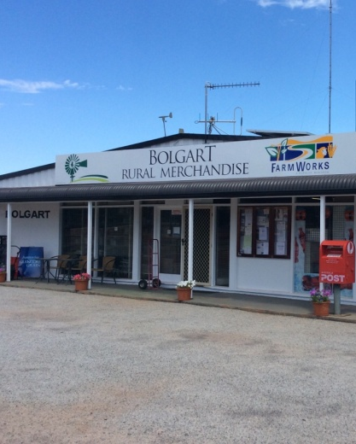 | 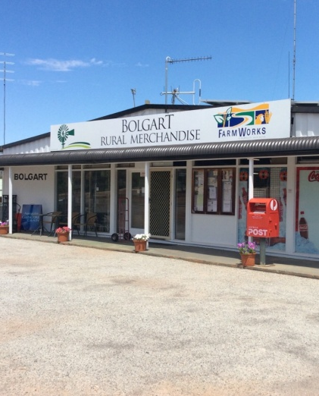 | 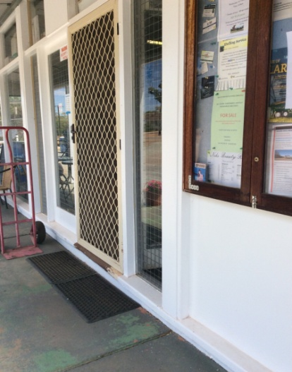
Appendix 1 | Appendix 2 | Appendix 3
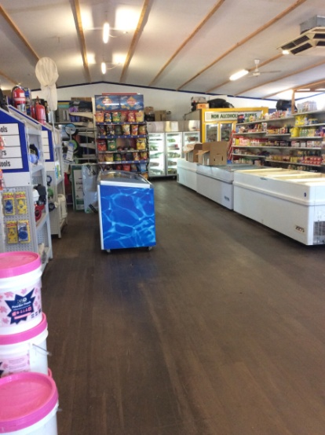
Appendix 4 | Appendix 5 | Appendix 6
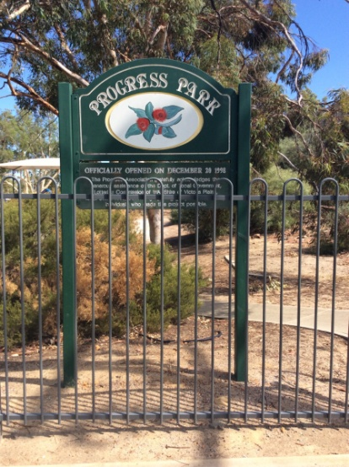 | 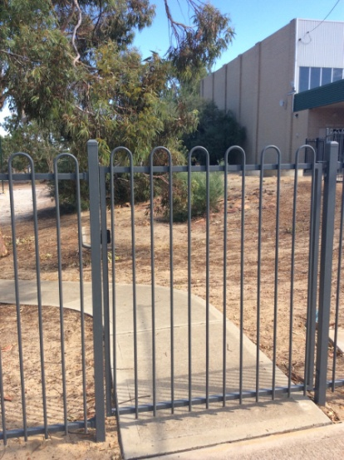 | 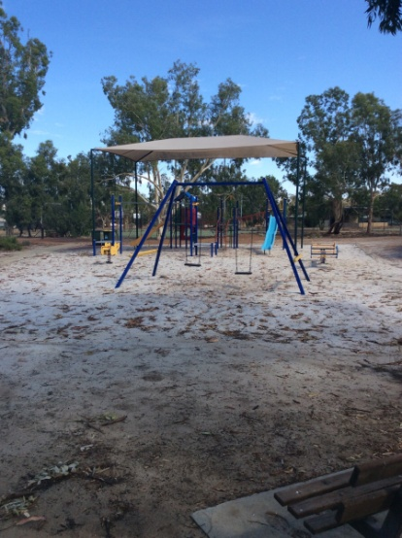
Appendix 7 | Appendix 8 | Appendix 9
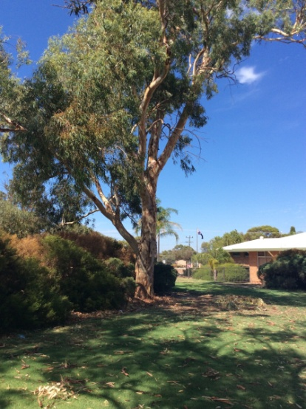 | 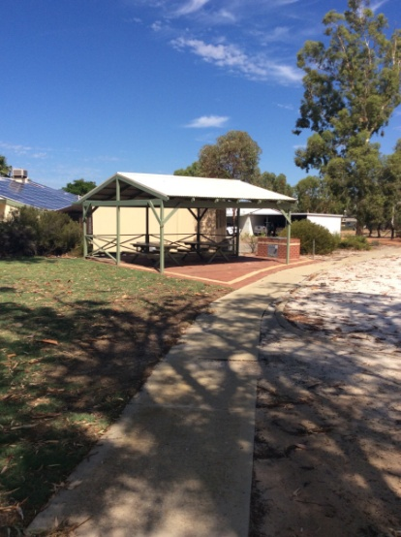 | 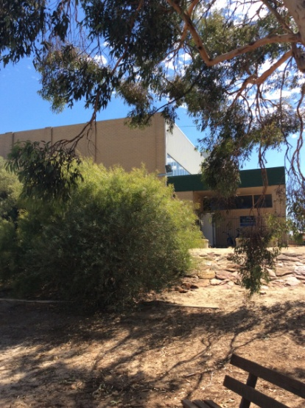
Appendix 10 | Appendix 11 | Appendix 12
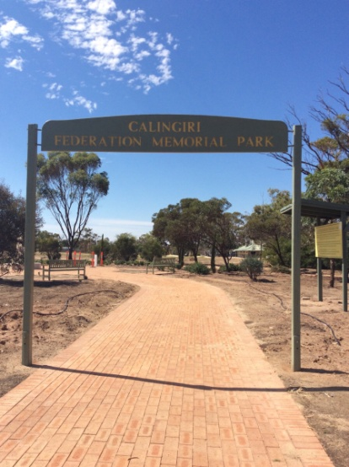 | 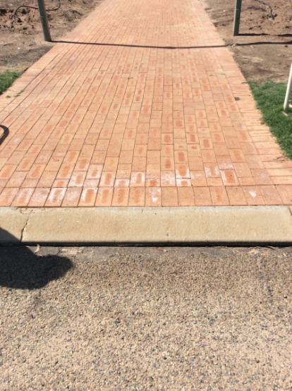 | 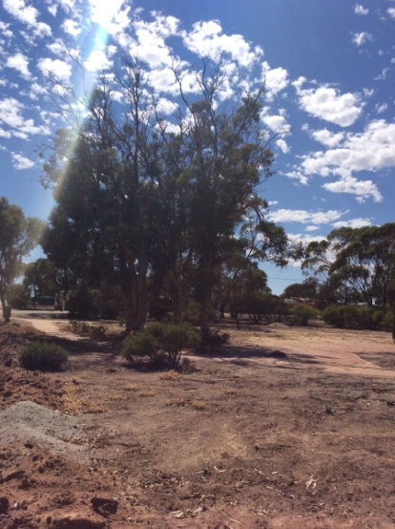
Appendix 13 | Appendix 14 | Appendix 15
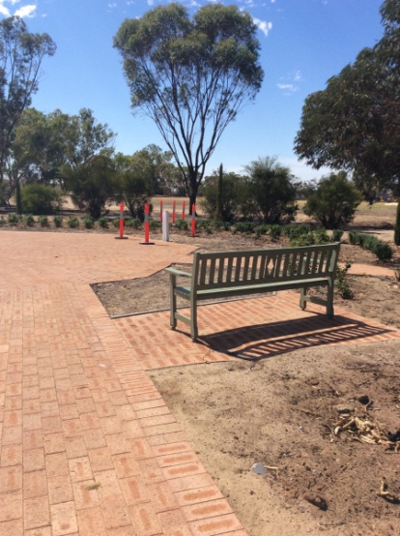 | 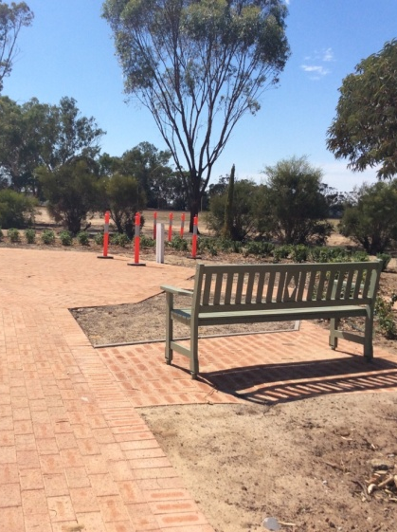 | 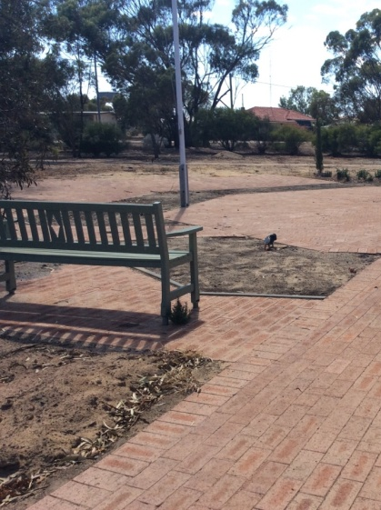
Appendix 16 | Appendix 17 | Appendix 18
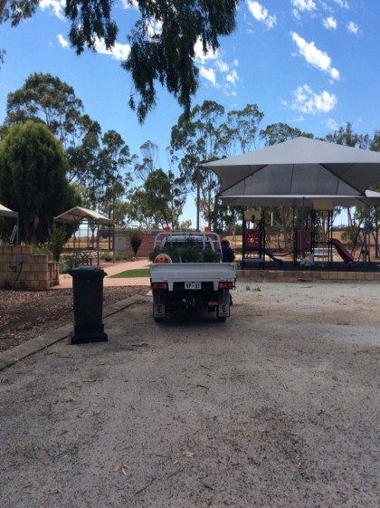 | 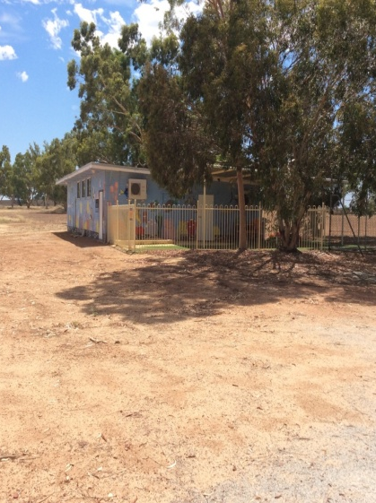 | 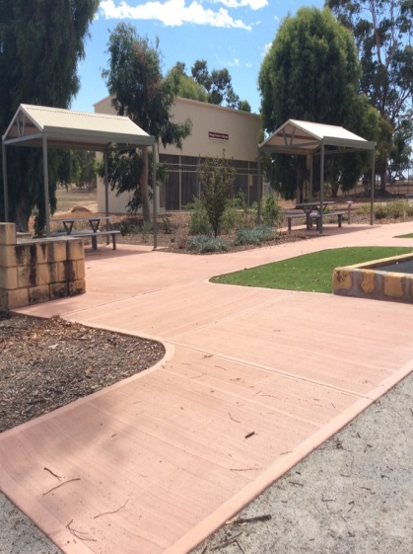
Appendix 19 | Appendix 20 | Appendix 21
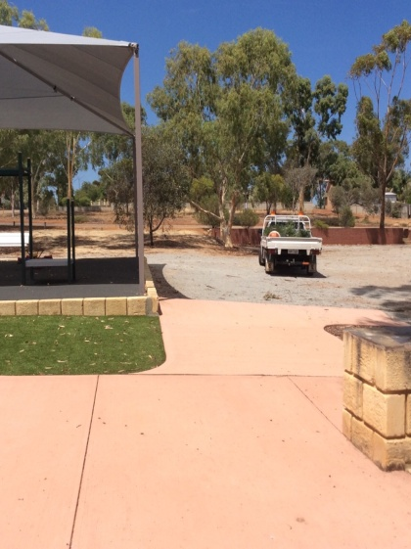 | 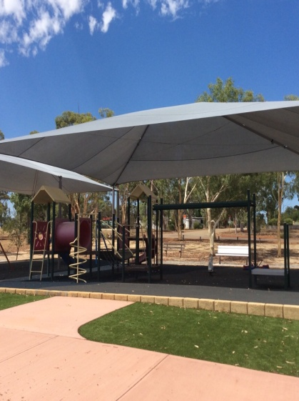 | 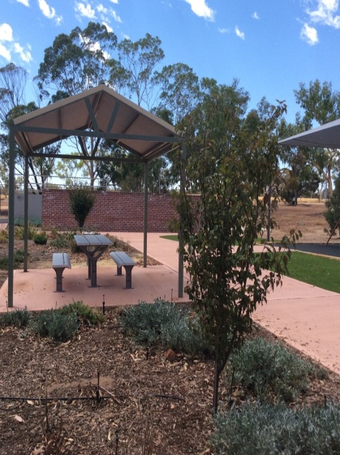
Appendix 22 | Appendix 23 | Appendix 24
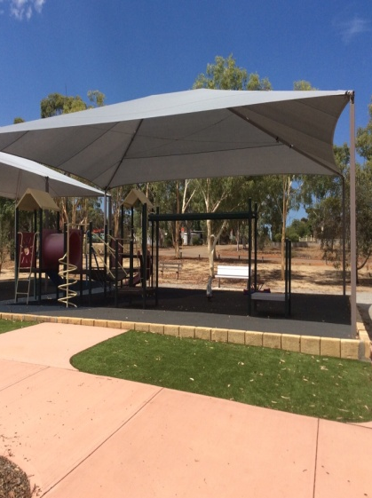 | 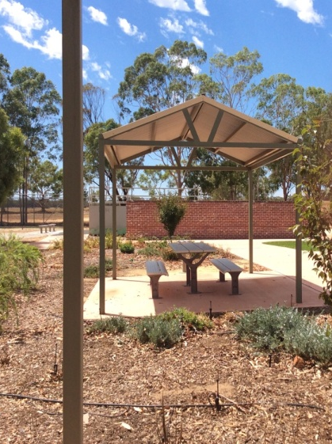 | 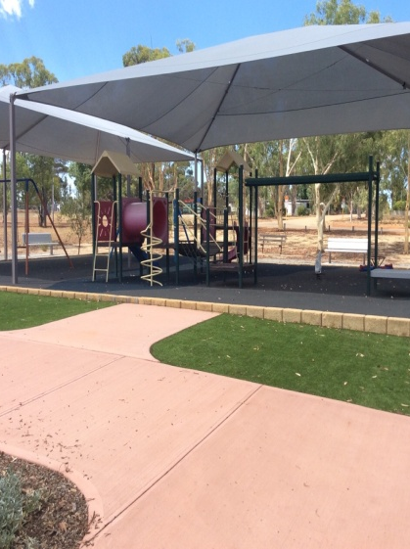
Appendix 25 | Appendix 26 | Appendix 27
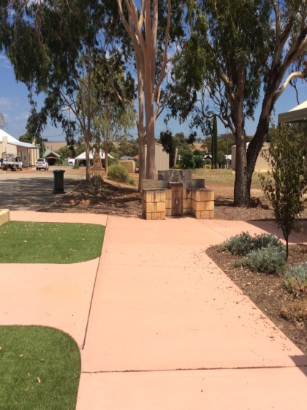 | 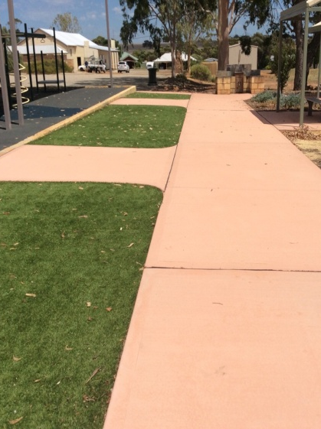 | 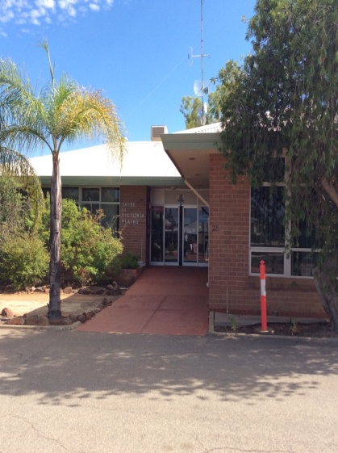
Appendix 28 | Appendix 29 | Appendix 30
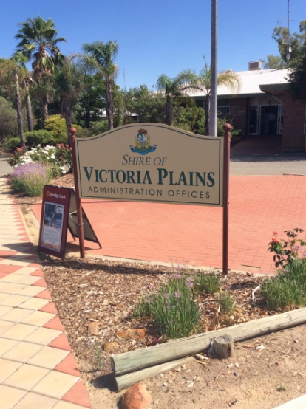 | 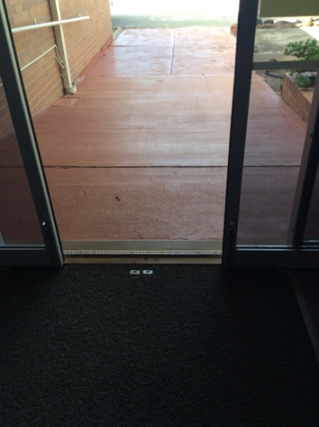 | 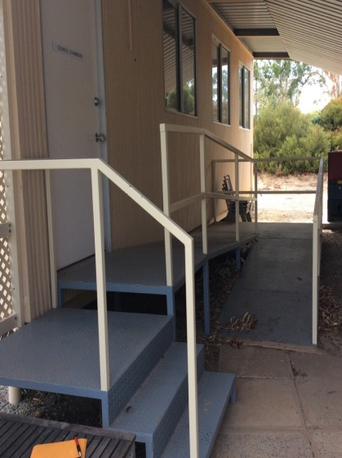
Appendix 31 | Appendix 32 | Appendix 33
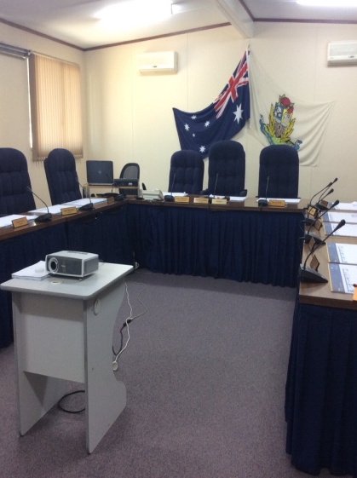 | 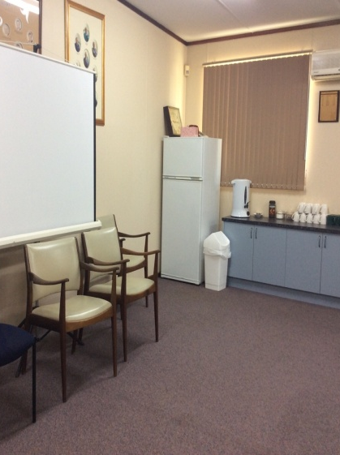 | 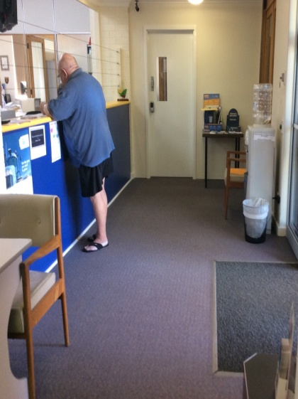
Appendix 34 | Appendix 35 | Appendix 36
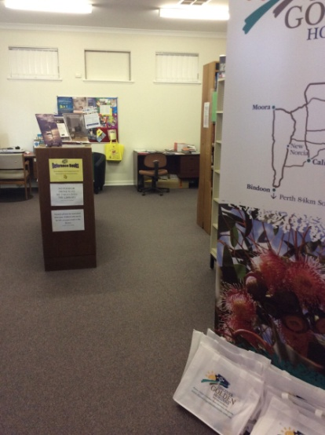 | 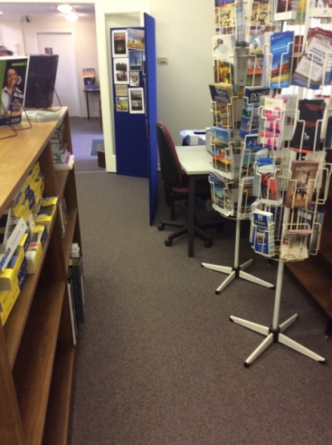
Appendix 37 | Appendix 38 | Appendix 39
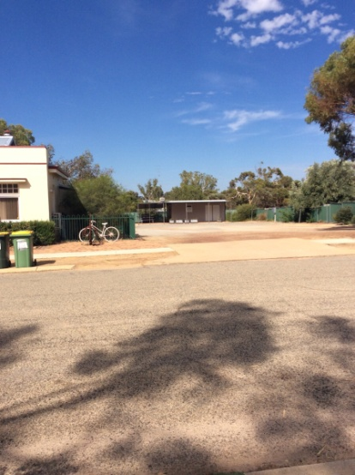 | 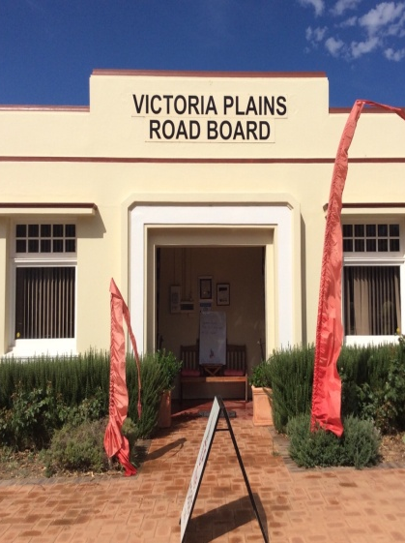 | 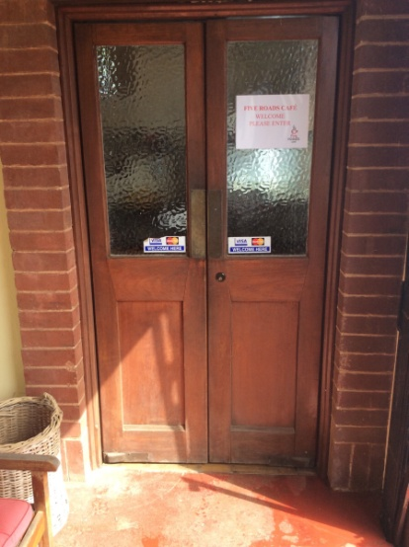
Appendix 40 | Appendix 41 | Appendix 42
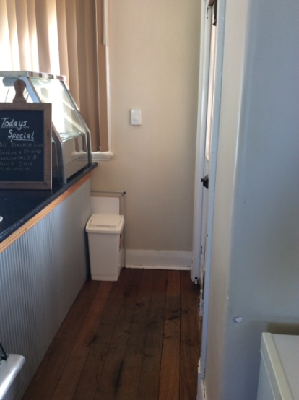 | 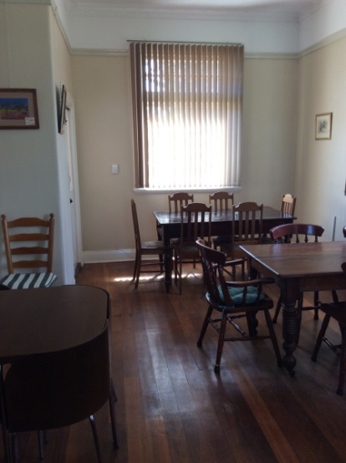 | 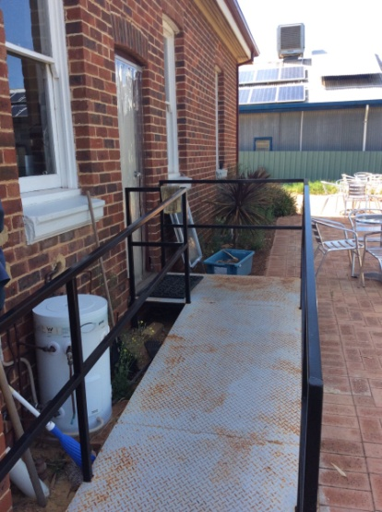
Appendix 43 | Appendix 44 | Appendix 45
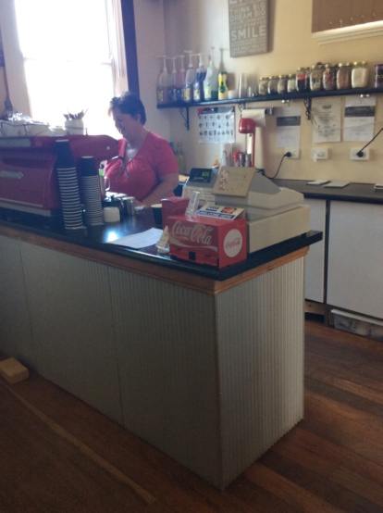 |  | 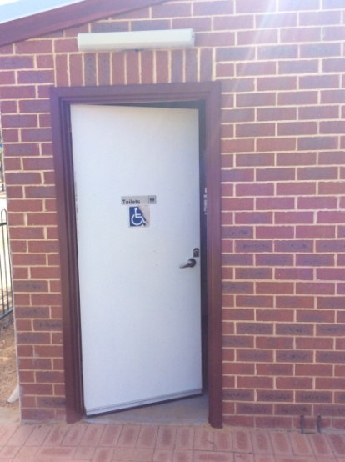
Appendix 46 | Appendix 47 | Appendix 48
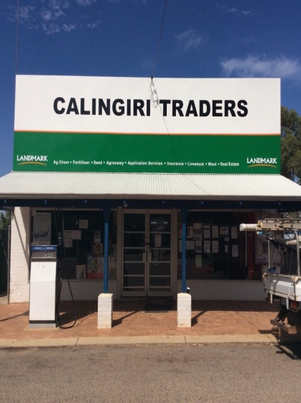 | 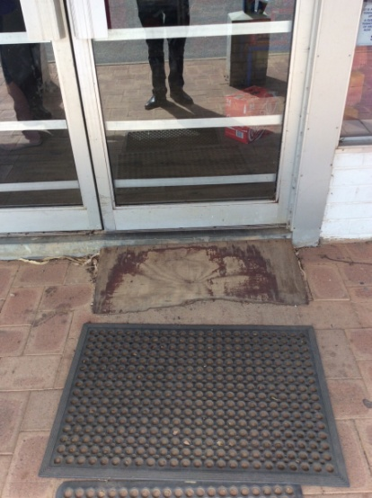 | 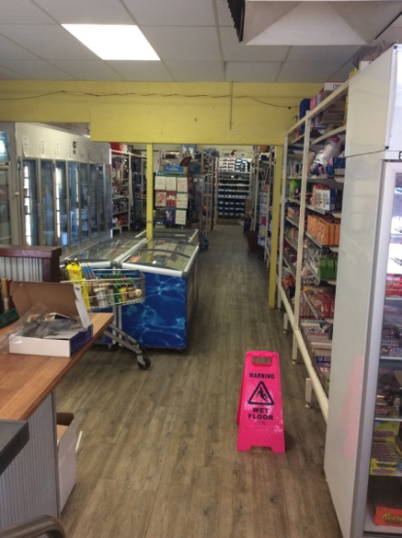
Appendix 49 | Appendix 50 | Appendix 51
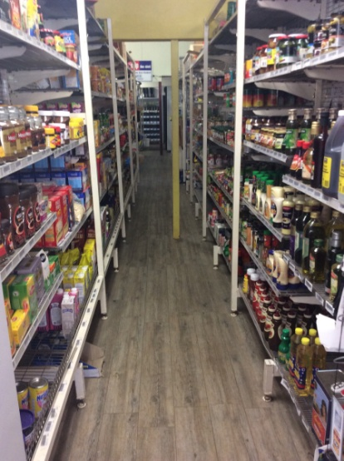 | 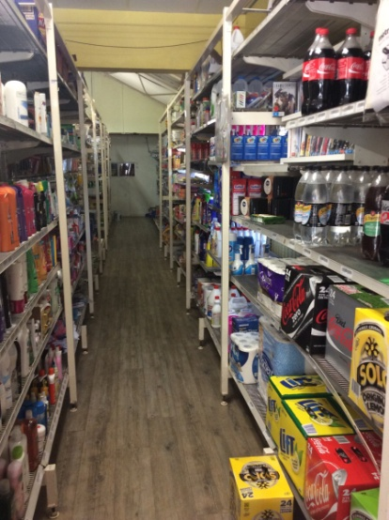 | 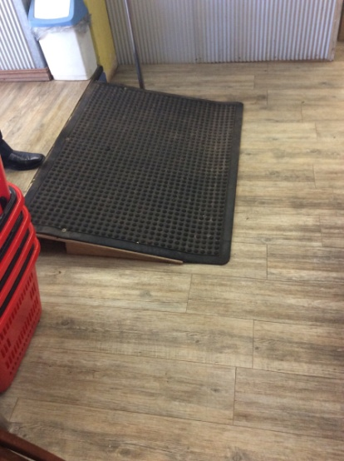
Appendix 52 | Appendix 53 | Appendix 54
 | 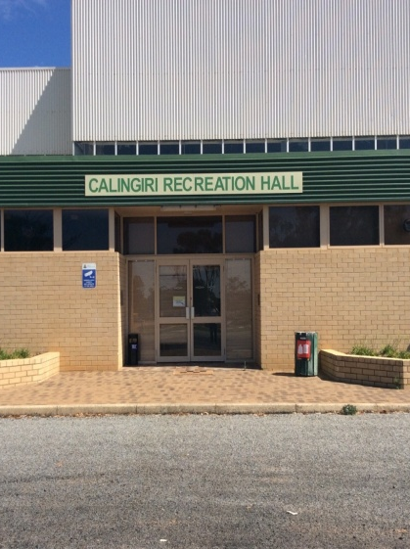 | 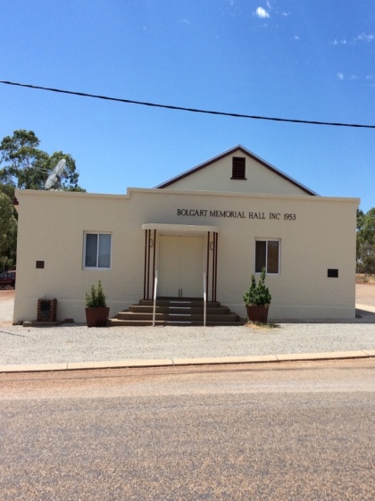
Appendix 55 | Appendix 56 | Appendix 57
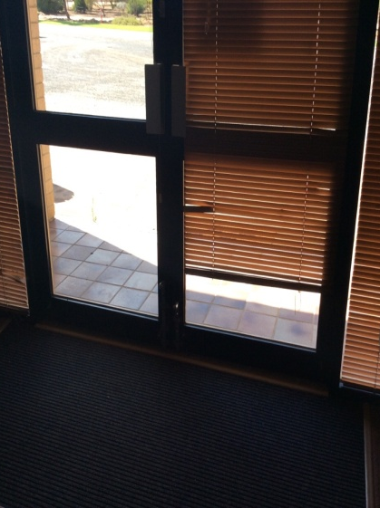 | 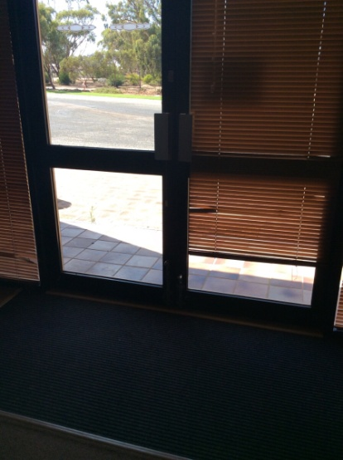 | 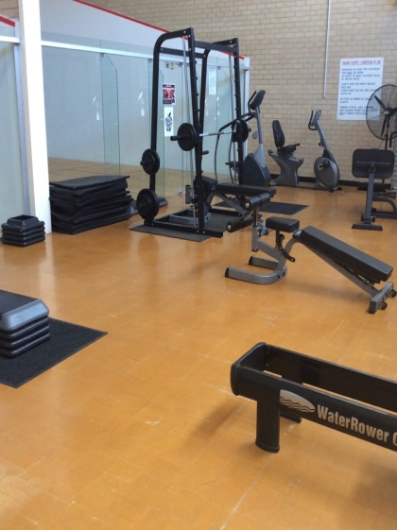
Appendix 58 | Appendix 59 | Appendix 60
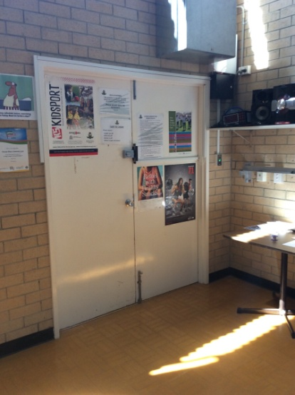 | 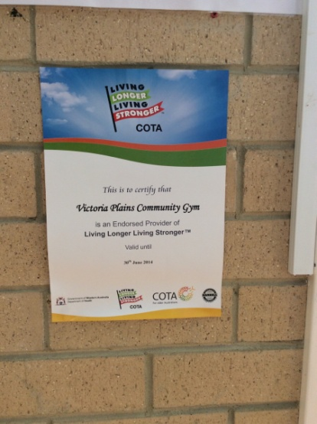 | 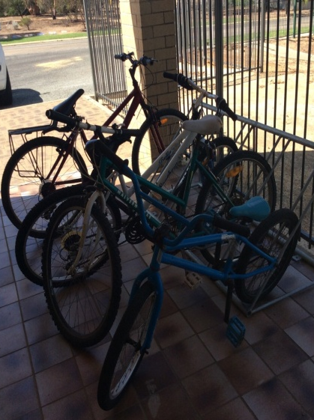
Appendix 61 | Appendix 62 | Appendix 63
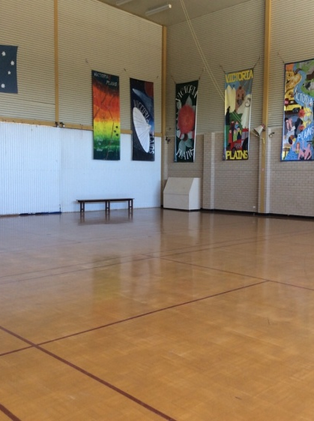 | 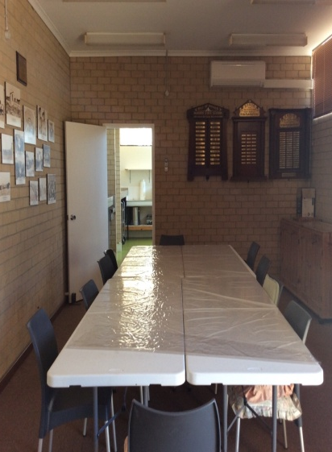 | 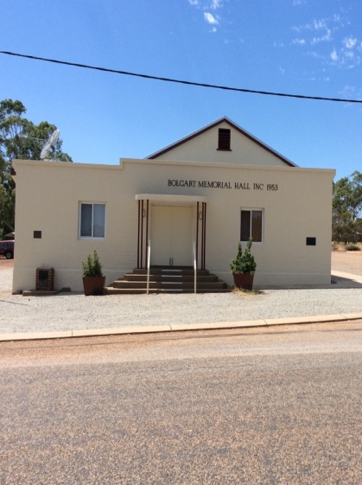
Appendix 64 | Appendix 65 | Appendix 66
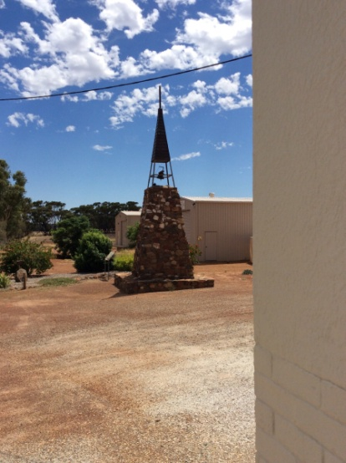 | 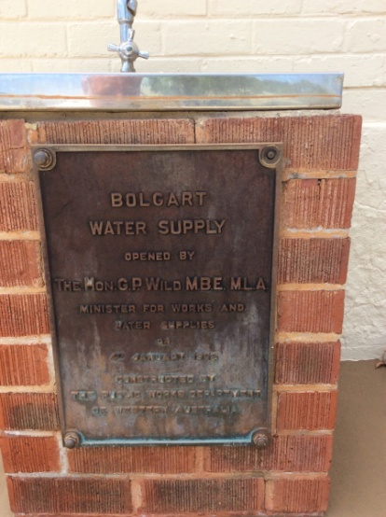 | 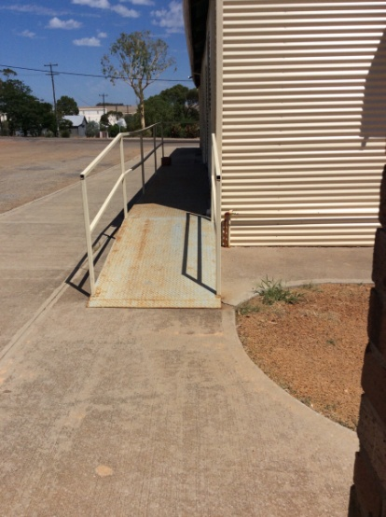
Appendix 67 | Appendix 68 | Appendix 69
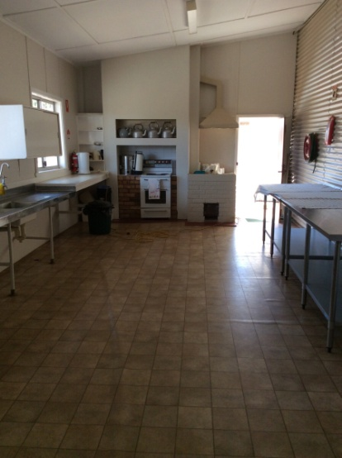 | 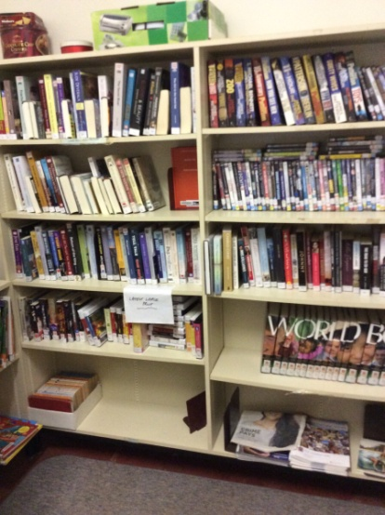 | 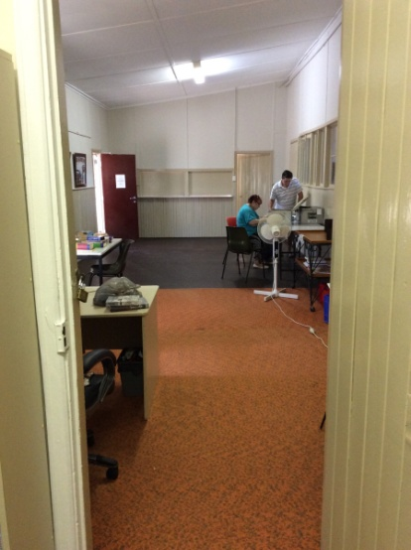
Appendix 70 | Appendix 71 | Appendix 72
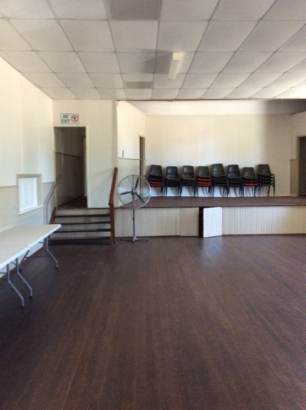 |  | 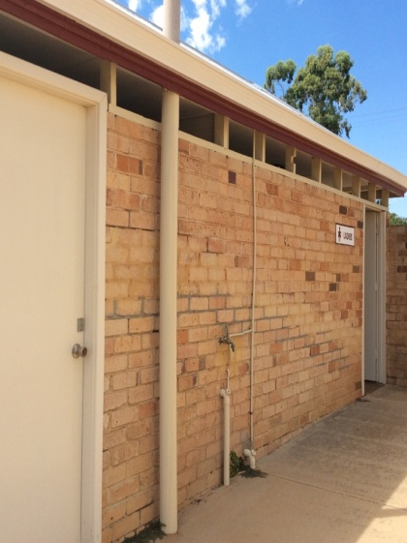
Appendix 73 | Appendix 74 | Appendix 75
 |  | 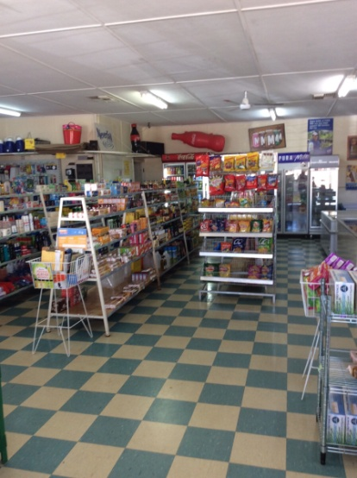
Appendix 76 | Appendix 77 | Appendix 78
 | 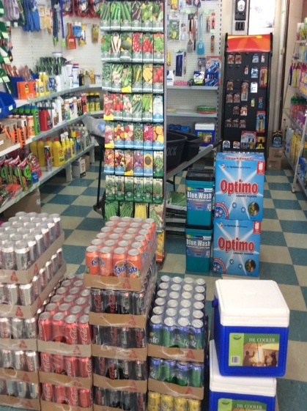
Appendix 79 | Appendix 80 | Appendix 81
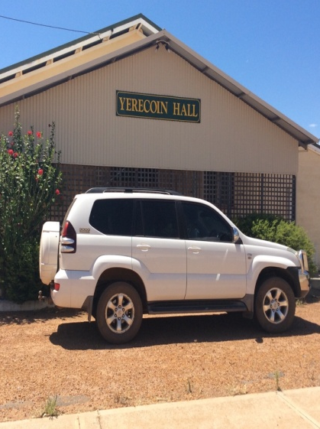 | 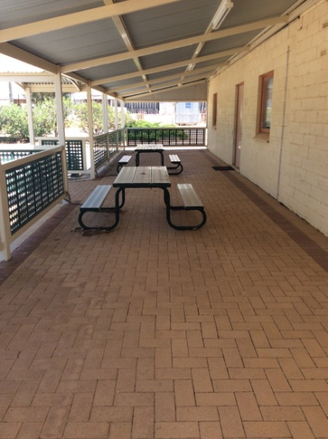 | 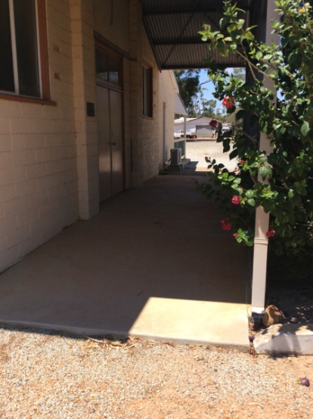
Appendix 82 | Appendix 83 | Appendix 84
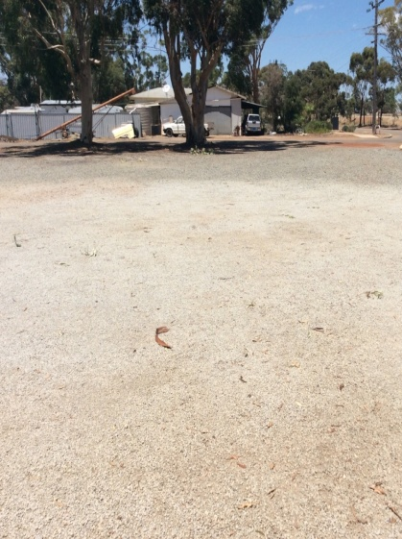 | 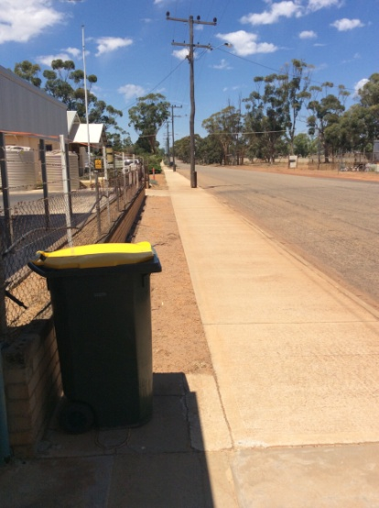 | 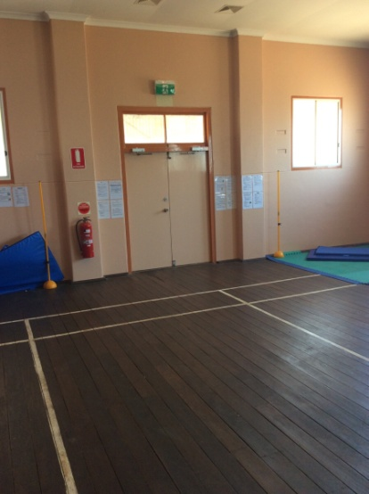
Appendix 85 | Appendix 86 | Appendix 87
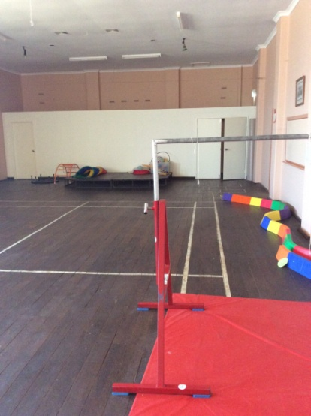 | 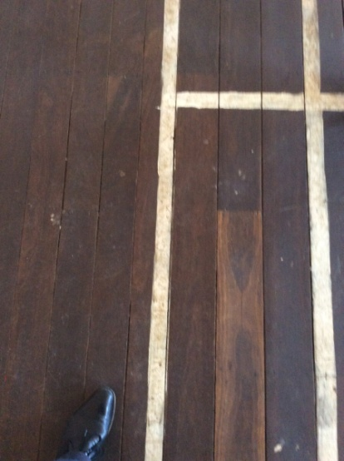 | 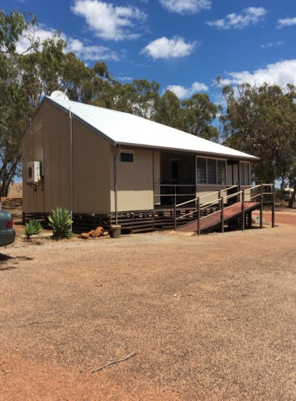
Appendix 88 | Appendix 89 | Appendix 90
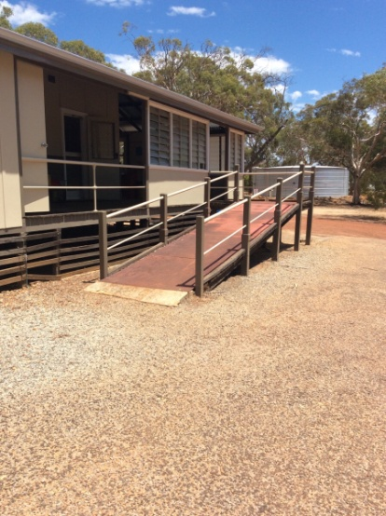 | 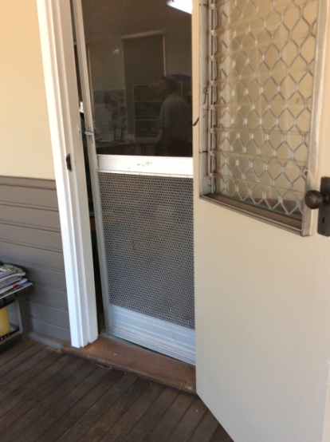 | 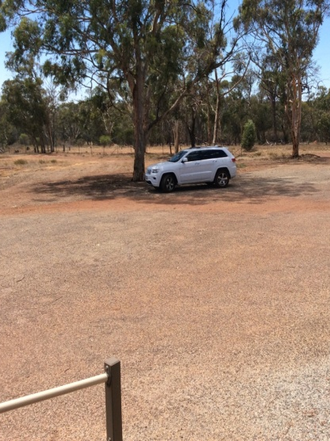
Appendix 91 | Appendix 92 | Appendix 93
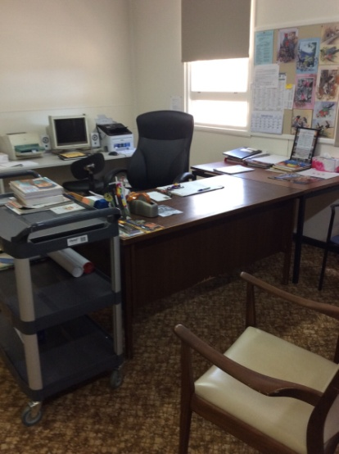 | 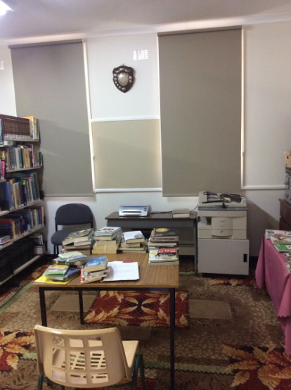 | 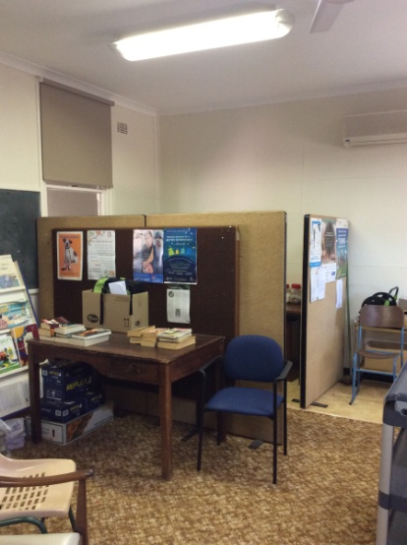
Appendix 94 | Appendix 95 | Appendix 96
 |  | 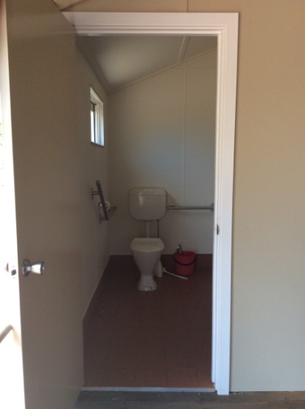
Appendix 97 | Appendix 98 | Appendix 99
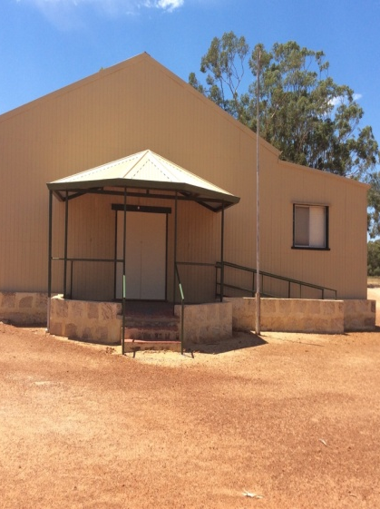 | 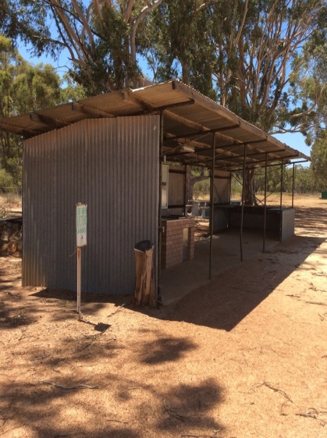 | 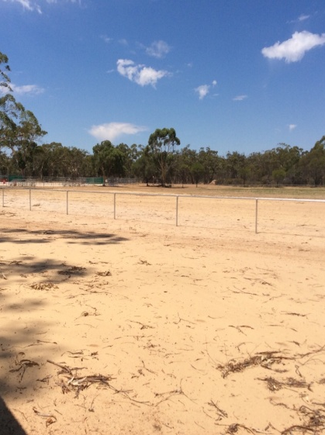
Appendix 100 | Appendix 101 | Appendix 102
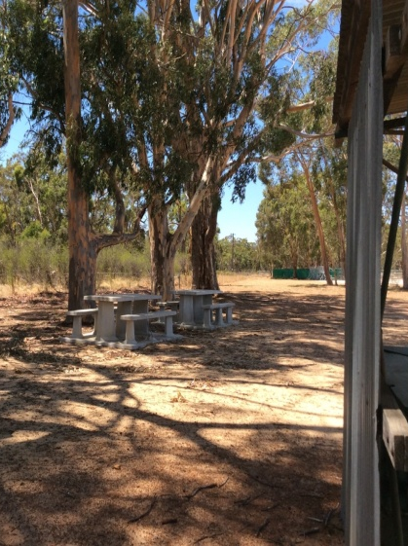 | 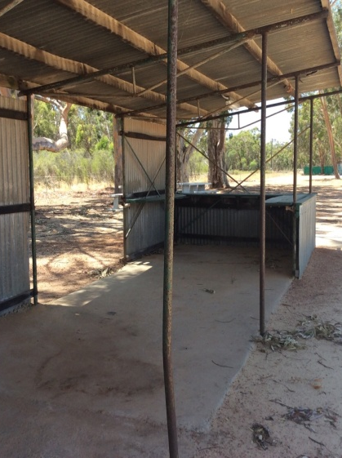 | 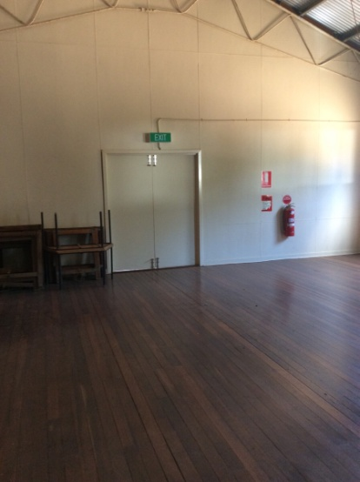
Appendix 103 | Appendix 104 | Appendix 105
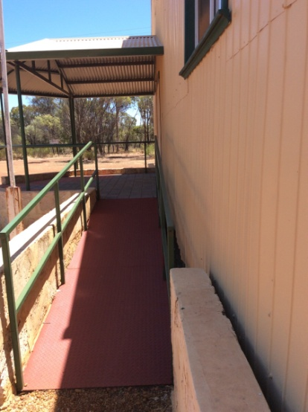 | 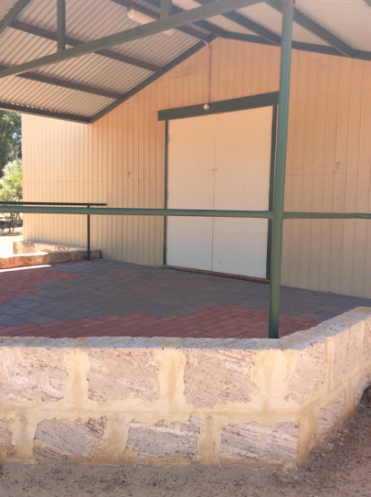 | 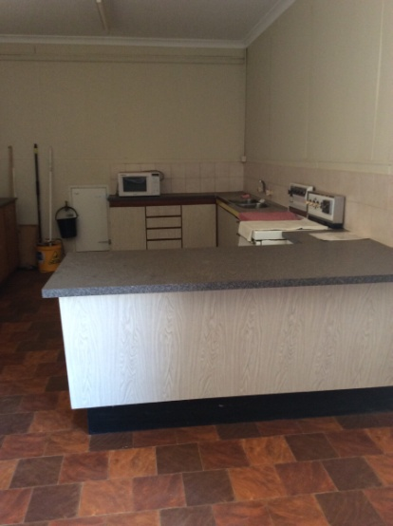
Appendix 106 | Appendix 107 | Appendix 108
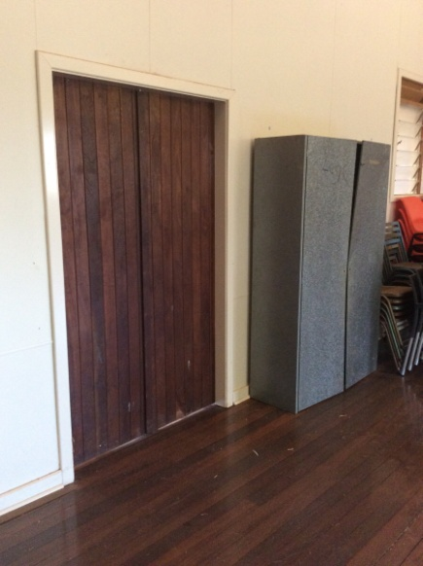 | 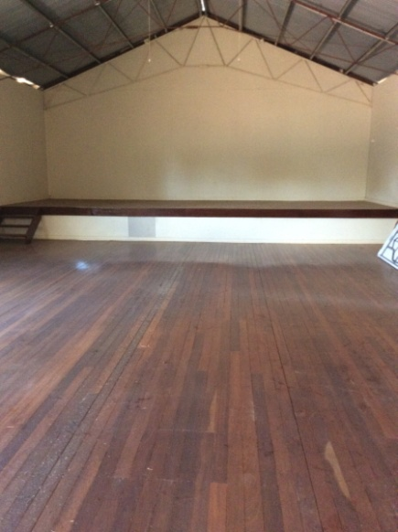
Appendix 109 | Appendix 110 | Appendix 111
 | 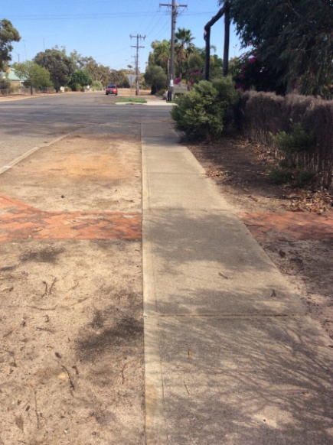 | 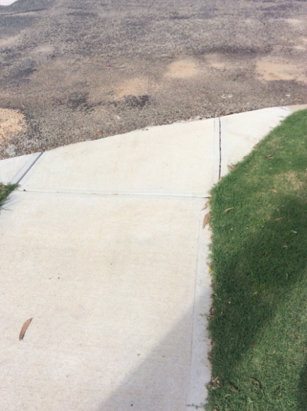
Appendix 112 | Appendix 113 | Appendix 114
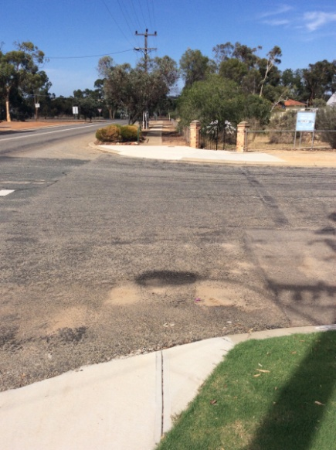 | 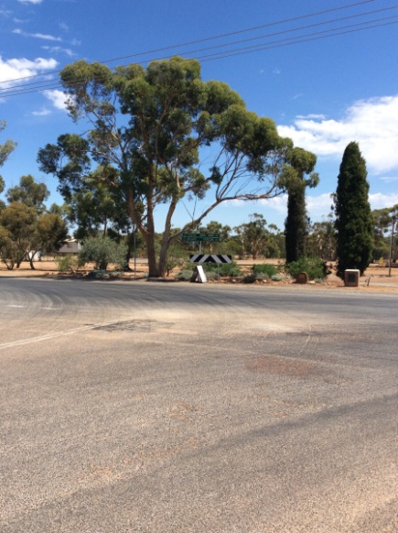 | 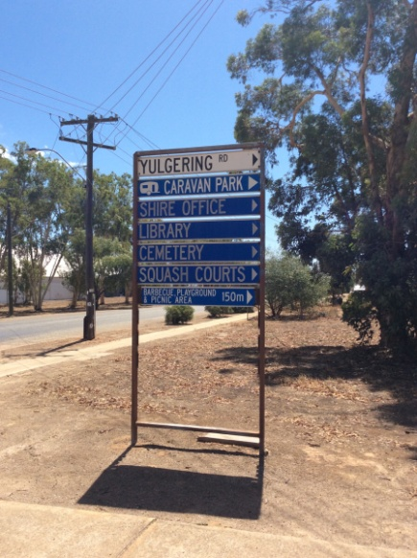
Appendix 115 | Appendix 116 | Appendix 117
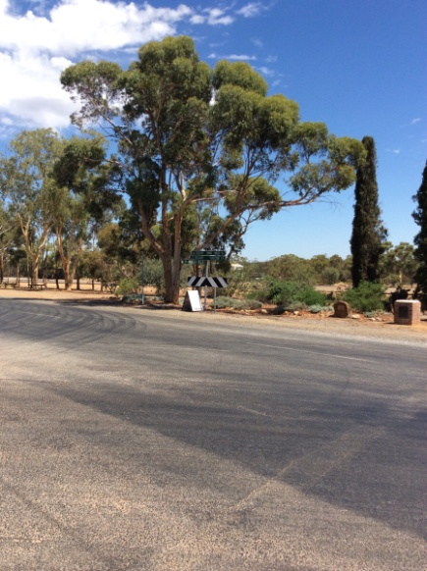 | 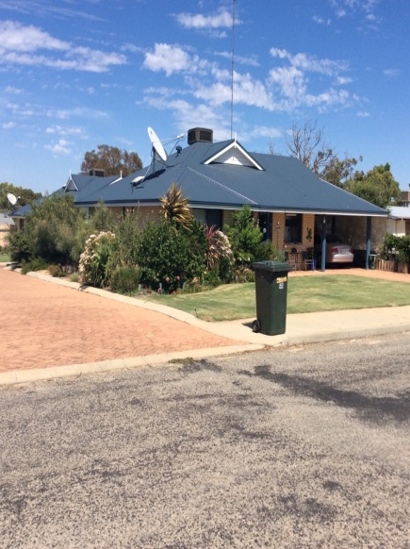 | 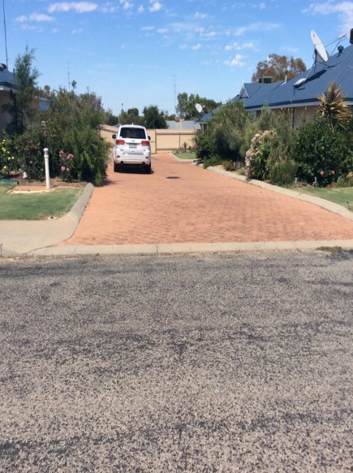
Appendix 118 | Appendix 119 | Appendix 120
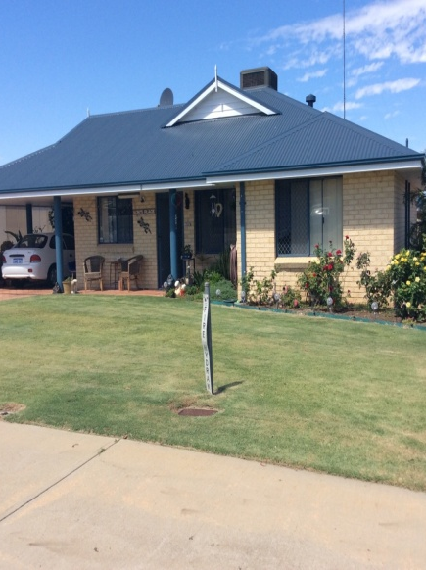 | 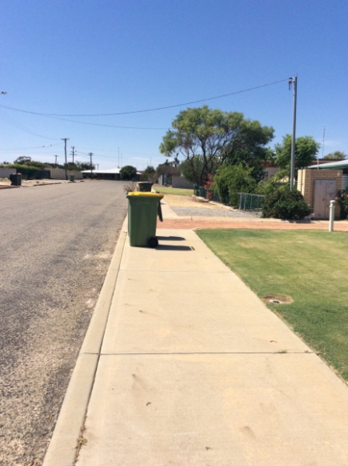 | 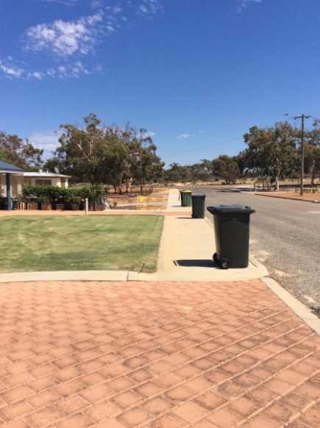
Appendix 121 | Appendix 122 | Appendix 123
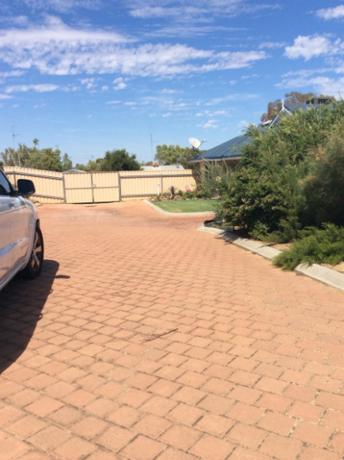 | 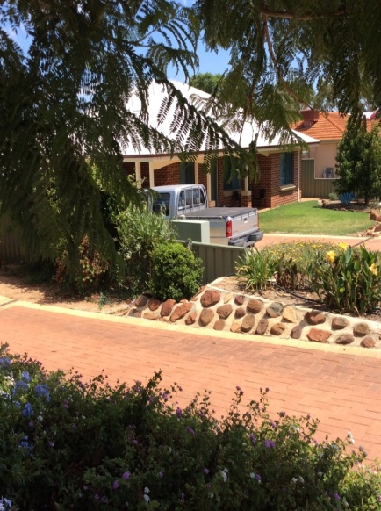 | 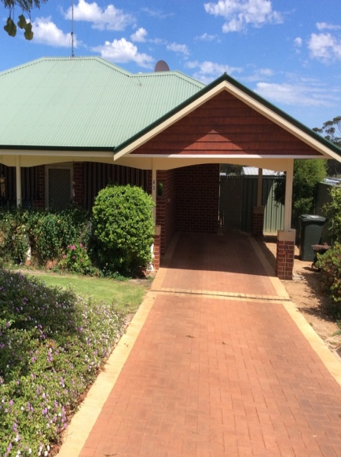
Appendix 124 | Appendix 125 | Appendix 126

Annex 2: Engagement Report: Towards an Age Friendly Community Plan
 | ENGAGEMENT REPORT
 | 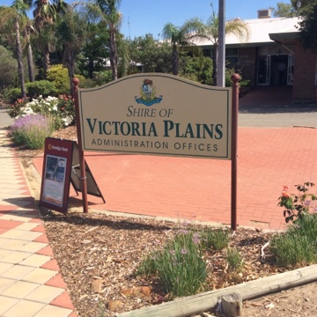
 |  | Nov 2015 | Towards an Age Friendly Community Plan

Contents

Key Findings 65
Introduction 66
Background 66
Community Engagement Methodology 66
Purpose 68
Focus Group Respondents 69
Service Providers 69
Seniors 70
Survey Respondents 73
Focus Group Results 74
Health and Community Services 74
Outdoor Spaces and Buildings 74
Transport and Movement 74
Housing 74
Sport and Recreation 74
Social Participation 75
Respect and Social Inclusion 75
Communication and Information 75
Survey Results 76
Health and Community Services 76
Outdoor Spaces and Buildings 77
Transport and Movement 77
Housing 78
Sport and Recreation 79
Social Participation 80
Respect and Social Inclusion 81
Communication and Information 82
Priorities 83
General Comments 83
Next Steps 84
Annex 1: Focus Group Promotional Flyer 85
Annex 2: Community Survey 86
Annex 3: Participant Information Forms 93

key findings
It is clear from the results of the engagement activities that both survey respondents and focus group participants enjoy living in the Shire of Victoria Plains. However, the research also shows that the community feel that there are some opportunities for improvement regarding the provision of key services in order to create an age friendly community.
The key findings are:
- A total of 12 individuals participated in the focus group (seven seniors and five service providers) and 19 individuals participated in the surveys.
- Of those seniors who participated, 100% of survey respondents and 79% of focus group participants are retired.
- The majority of both survey and focus group respondents believe that improved provision of health and community services and maintenance of footpaths and roads will lead to a more fulfilling experience for seniors in the Shire of Victoria Plains.
- Focus group participants believe the most important issues for aged persons in the Shire of Victoria Plains are:
  - Increased access to a full health and community services
  - Increased communication with seniors regarding services the Shire provides
  - Maintenance of footpaths and roads
- Survey respondents believe the most important issues for aged persons in the Shire of Victoria Plains are:
- Increased provision of medical services
- Provision of a district nurse or equivalent
- Access to medical services for those who are unable to drive
- Communication by the Shire

Introduction

Background
Age-friendly communities are those that encourage “active aging by optimizing opportunities for health, participation and security in order to enhance the quality of life as people age” (World Health Org). An Age Friendly Community is one which:
- recognises the great diversity among older people;
- promotes their inclusion and contribution in all areas of community life;
- respects their decisions and lifestyle choices; and
- anticipates and responds to ageing-related needs and preference
The Shire of Victoria Plains considers age-friendly community planning a vital exercise for the following reasons:
- By 2027, the Wheatbelt population over 70 will have increased by 75.3%
- The proportion of people 70+ will have increased from 10.4% in 2011 to 17% in 2027
- The second largest increase is projected for Victoria Plains (118.6% to 129 people)
In addition to this, older adults generally prefer to remain in their own home and continue to be part of their community. Older adults feel safe, valued and respected in their own community and local governments have a key role in ensuring this can occur.
Age-friendly community planning is also a state and regional issue. In 2012 the State Government adopted “An Age-friendly WA: The Seniors Strategic Planning Framework 2012-17.” The following actions have also been undertaken:
- 2013 the Wheatbelt Integrated Aged Care Plan was published
- 2014 the Wheatbelt Development Commission (WDC) published a guide for Age-Friendly Community Planning
- 2015 WDC provided a small value grants program for minor improvement works targeted at improving age-friendliness (the Shire of Victoria Plains was successful in getting funding for three projects)
- 2015 Department of Local Government and Communities Grant program to prepare plans (Victoria Plains again successful).

Community Engagement Methodology
The broad approach adopted by the Shire of Victoria Plains in preparing an Age Friendly Community Plan consists of a four step solution-focused process to produce a strategy that will be consistent with and complementary to the Strategic Community Plan:

Figure 1: Age friendly planning community process
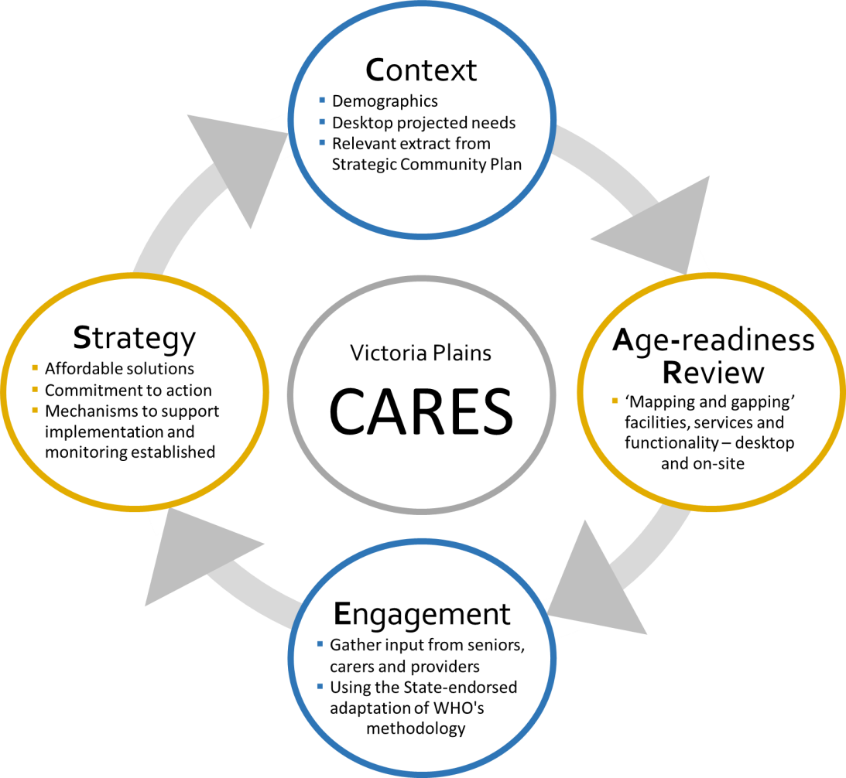
The third step of the process concerns engagement. As part of the Age Friendly Planning process, and to obtain the knowledge and views of seniors and those who care for them, a Community Reference Group has been established. This group guides and supports the project, liaises with the Department of Local Government and Communities, reviews draft reports and will endorse the final plan. In addition to this, the group has provided input into the design of a community survey and focus groups. Both the survey and the focus group sessions were structured around the eight WHO domains with participants involved in assessing these features in their own communities.
The Shire of Victoria Plains conducted one Focus Group that included both service providers and community members. The Shire advertised the Focus Group and Community Survey (available in hard copy and online) using the following channels:
- Shire of Victoria Plains Community Newsletter
- Shire of Victoria Plains website
- Shire of Victoria Plains Facebook Page
- Personal phone calls to service providers within the shire and outlying areas who service the Shire of Victoria Plains.

See Annex 1 for a copy of the Focus Group promotional flyer. Annex 2 contains a copy of the Community Survey.

Purpose
The purpose of the Engagement Report is to present the results of the Focus Groups and Community Survey. It will be used to inform and guide the next steps in the development of the Shires’ Age Friendly Community Plan.

Focus group Respondents
The Shire of Victoria Plains conducted one Focus Group as part of the development of the Age Friendly Community Plan. The session was jointly aimed at seniors, carers and service providers with seven seniors, four service providers and one carer in attendance. The Focus Group was designed and conducted in line with the Department for Communities Age Friendly Toolkit and the Wheatbelt Development Commissions Age Friendly Community Plan Guide. See Annex 3 for a copy of the Participant Information Form used to collect the data presented below.

Service Providers
A total of four service providers and one carer attended the Focus Group representing the voluntary (not for profit), public (local government) and private sectors. Of the service providers present, 100% have been employed with their current Service Provider over five years. Half of the service provider participants indicated that they have a moderate amount of experience with older people and half indicated they have a lot of experience.
Of the service providers and carers in attendance at the focus group, 50% are female, 25% male and 25% did not answer the question (refer to Figure 2).
Figure 2: Service Provider and Carers respondent sex

Seniors
Seven people in the Shire of Victoria Plains attended the community focus group. Of those, 86% or six are female and 14% or one are male.
Figure 3: Senior focus group respondent sex

Respondents range from 65 to over 85 years of age (refer to Figure 4). The majority of focus group participants are between 65 and 69 years of age.
Figure 4: Focus group respondent age

All 100% of focus group respondents are retired.
57% of respondents indicated their health was fair, 29% indicated their health as good and only 14% indicated their health was excellent.

Figure 5: Current respondent health

Two out of seven respondents reported that they have health problems that limit their ability to do normal daily activities.
Table 1: Focus group respondent limiting health problems
Answer Options | Response Count | Response Percent
Yes | 2 | 29%
No | 5 | 71%
Total | 7 | 100%

Two respondents have completed primary school as their highest level of education, three have completed secondary school and two have completed technical or further educational institution.
Figure 6: Focus group respondent highest schooling level

86% of the focus group respondents are home owners. 14% of respondents are renters.
Table 2: Focus group respondent home ownership
Answer Options | Response Count | Response Percent
Home Owner | 6 | 86%
Renter | 1 | 14%
Total | 7 | 100%

While three respondents indicated they live alone, one indicated they live with a partner or spouse. Three respondents did not answer the question.
Figure 7: Focus group respondent living arrangements

29% of respondents live in Bolgart, 29% live in Calingiri and 43% did not answer the question.

Figure 8: Focus group respondent location by suburb

Survey Respondents
In the Shire of Victoria Plains, 19 respondents completed the surveys. Approximately 68% of respondents are female, 26% are male and 5% did not answer (see Table 3).
Table 3: Survey respondent sex
Answer Options | Response Count | Response Percent
Male | 5 | 26%
Female | 13 | 68%
Not Answered | 1 | 5%
Total | 19 | 100%

Respondents range predominantly from 65 to 74 years of age. One respondent indicated they were under 54 years of age, and two indicated they were over 85 years of age. Nine or 45% of respondents are between the ages of 65 to 69.
Figure 9: Survey respondent ages

79% of respondents are retired, 11% work full-time and 11% work part-time (refer to Table 4).
Table 4: Survey respondent present employment status
Answer Options | Response Count | Response Percent
Retired | 15 | 79%
Work Full-time | 2 | 11%
Work Part-time | 2 | 11%
Unemployed | 0 | 0%
Not Answered | 0 | 0%
Total | 19 | 100%

Focus Group Results

Health and Community Services
It is clear that focus group participants have several areas of concern with health and community services currently provided in the Shire of Victoria Plains. Participants noted that there is a lack of access to a full health and community services. This includes inconsistency in service provision within the Shire as services are accessed from a range of external locations including Moora, Goomalling and Wongan Hills. Participants were also concerned by the lack of Silver Chain or similar service. Lack of communication with seniors regarding which services are provided was also noted by participants. Seniors would also like to see a Meals on Wheels service available in the Shire. Discussions regarding housing led to the following observations:
- Issues with access to existing aged housing with the Shire
  - Poor design of current units
- Lack of residential aged care and high-care housing
- Need to go beyond minimum access standards for new independent living units (ILU)

Outdoor Spaces and Buildings
Participants have noted that current street numbers and signage are poor and lead to difficulty for emergency services and those needing to locate addresses correctly. Pot holes and poor footpaths on key shopping routes have also been cited for needing maintenance and other upgrades. In addition to footpath maintenance, participants commented on the two types of footpaths that are required, those with access to services and those for recreation and physical activity. While participants felt that outside street lighting is adequate in Calingiri, it is inadequate in Bolgart, citing that there are several street lights that have not been functioning in Bolgart for two years. Participants are also concerned with the lack of seating along footpath routes that will become an increasingly important prospect as members of the community age. Lastly, participants cited the possibly of initiating an inspection or audit of the town with Shire representatives and community members to pinpoint problem areas. This inspection would include community members with all levels of accessibility including those who use wheelchairs, gophers, etc.

Transport and Movement
Participants did not cite any specific comments regarding transport and movement within the Shire of Victoria Plains.

Housing
Focus group respondents commented that buildings designated as teacher’s housing represents a potential opportunity for the Shire as they are often left vacant. No other specific comments regarding the Shire’s provision of housing were made.

Sport and Recreation
Respondents commented that there were varying opportunities for the Shire to maximise the use of the gym in providing classes and guidance for seniors in the community. Participants felt that there are excellent facilities provided, but they are not being utilised to their full potential by aged persons in the Shire of Victoria Plains. In addition to this comment, it was cited that there needs to be consideration given to succession planning for ground maintenance as it is currently undertaken by senior club members, which may not be sustainable. While women’s organised sport is noted as lacking in Calingiri, the excellent sports club in Bolgart was praised by participants.

Social Participation
Participants cited that seniors take more active roles within the community and there is a lack of involvement from younger people in similar roles. The feeling remains that the same individuals volunteer everywhere.

Respect and Social Inclusion
Some focus group respondents felt that unfortunately there is no longer a sense of community in Calingiri and that seniors’ opinions in the Shire of Victoria Plains are sometimes neither asked for nor listened to. Conversely, seniors in other towns feel that a sense of community is very strong, particularly over summer months when there is an increase in social activities.

Communication and Information
Participants feel that there needs to be a continual and two-way sharing of communication and information between seniors and the Council. In addition to this, participants would like to see mechanisms to improve the distribution frequency of the shire newsletter. Respondents have also commented on the Shire’s other options for communication, including email, newsletters and notice boards. In addition to this, the desire for computer accessibility in libraries was also mentioned. It was noted that there are opportunities to provide computer training to seniors, possibly in partnership with local schools.

Survey Results

Health and Community Services
Approximately 47% of survey respondents indicated that they are either very dissatisfied or dissatisfied with the provision of health and community services in the Shire of Victoria Plains. 32% of respondents indicated they were neither satisfied nor dissatisfied with the Shire’s provision of services and only 22% indicated they were satisfied or very satisfied (see Figure 10).
Figure 10: How satisfied are you with the provision of Health and Community Services (including GP, medical services, home care and shopping) in the Shire of Victoria Plains?

Survey respondent comments on health and community services can be grouped according to the following concerns: home care, medical and general comments.
Two specific commentators noted the need for a health and community services gardener in the Shire of Victoria Plains. Other respondents noted the need for a Silver Chain nurse to conduct home visits as well as other medical professionals.
The provision of medical care in the Shire is of concern to the survey respondents. One comment reads that there “is no health service available in VP.” Another respondent has also indicated that they are unaware of any services apart from St John Ambulance. Several participants have noted that in order to receive medical care, they must travel 50-60 kilometres to the Shire of Moora or Perth. The lack of a GP in Calingiri is also noted in one comment.
One comment notes that extended services are not “viable with [a] very small population” and consider towns only 30 minutes away with excellent facilities to be adequate. Another comment references this thought in an opposing manner, wishing the Shire to develop services for future seniors.

Outdoor Spaces and Buildings
64% of survey respondents have indicated that they are either very satisfied or satisfied with the Shire’s provision of outdoor spaces and buildings. No respondents are currently very dissatisfied or satisfied. Approximately 26% or five respondents are neither satisfied nor dissatisfied with outdoor spaces and buildings and 11% have provided no answer at all (see Figure 11).
Figure 11: How satisfied are you with the provision of Outdoor Spaces and Buildings in the Shire of Victoria Plains?

Several respondents noted that “Shire outdoor spaces are very good” and this is evident in the relatively high level of satisfaction seen in Figure 11. Another comment referenced the “lack of co-ordination with major tourist and heritage site New Norcia.” The same commentator indicates confusion over arrangements that see “buildings maintained by Shire and some by community groups.” Another respondent is pleased that Progress Park is “having a makeover” and noted that the hall is a “white elephant.”

Transport and Movement
47% of respondents answered they were either very dissatisfied or dissatisfied with transport and movement in the Shire (see Figure 12). 21% of respondents were neither satisfied nor dissatisfied and 21% were satisfied. Only 11% of respondents did not answer.

Figure 12: How satisfied are you with Transport and Movement (including roads, footpaths and public/community transport) in the Shire of Victoria Plains?

Comments on transport and movement in the Shire of Victoria Plains were focused primarily on the provision of roads, footpaths, and bus and transport. One respondent noted that while “the Shire works hard to address road maintenance with limited budget,” it appears that “the allocation of funding to certain areas can be seen to favour certain districts over others.” The same participant suggested that provision of maintenance “should be managed on a whole of Shire plan with regular updates as to where the works are going to be conducted and a timeline of future works so that community members know what's happening.” Several comments note specific roads that cause concern. These include the Yarrawindah Road, which without additional widening is “dangerous at the moment between Mogumber and Gt Northern Highway.” Another commentator noted the Yerecoin East Road from Yerecoin to Calingiri is also in disrepair.
One respondent noted that footpaths “are missing in Cavell Street and Mofflin Street.” The respondent noted the need to “walk on the road and try to ditch the traffic.” Another commentator indicated that footpaths are “okay” and they successfully manage a gopher on them. In addition to increase provision of footpaths, one commentator noted their desire for a greater provision of benches “along from the shop.”
Several respondents indicated that “a community bus would be welcomed, especially as there [are] a lot of people who can’t drive…” This community bus would be required for shopping, medical appointments as well as for general travel. Another consensus appears to be the need for “a roster of willing drivers” throughout the community to provide rides to those in need. This “volunteer driver scheme to help with medical appointments etc. would be appreciated.”

Housing
26% of respondents noted they were neither satisfied nor dissatisfied with the provision of housing in the Shire, as indicated in Figure 13. While 5% were dissatisfied, 58% were either satisfied or very satisfied. 11% of respondents did not answer.
Figure 13: How satisfied are you with the provision of Housing in the Shire of Victoria Plains?

As indicated by the above figure, many respondents are satisfied or very satisfied with the provision of housing in the Shire of Victoria Plains. One commentator does note the need for more cupboards in houses provided as well as larger rooms for ambulance gurney access (if needed.) Another respondent indicates little understanding of how “the housing situation works” within the shire. The same respondent notes the appearance of “active discouragement to the development of houses in the smaller towns with lack of connection to water, power and housing unavailable even though blocks are empty/undeveloped.” Another respondent indicated the need for greater aged-persons housing within the shire.

Sport and Recreation
63% of respondents are satisfied or very satisfied with the Shire’s provision of sport and recreation facilities, and no one is either dissatisfied or very dissatisfied (refer to Figure 14). While 26% of respondents are neither satisfied nor dissatisfied, 11% of respondents did not answer.

Figure 14: How satisfied are you with the provision of Sport and Recreation facilities and services in the Shire of Victoria Plains?

Comments regarding sport and recreation in the Shire of Victoria Plains range from generally very positive to noting minor improvements that could occur. One comment noted that the local oval is “second to none” and that facilities are “very good.” An extensive comment, indicated that while “town sizes and population means that Shire of VP cannot support many different sports across the towns,” they appreciate Calingiri is the centre for football and hockey. The same respondent noted their desire to see “facilities maintained in other towns” but understood budget constraints. Wildflower Walks, Outback Club and Rodeo events were also mentioned as being beneficial events to be continually supported and encouraged by the shire. Several comments noted that while adequate facilities are available, they are under accessed by community members.

Social Participation
Approximately 53% of respondents are satisfied or very satisfied with the social participation opportunities available in the Shire. Only 11% of respondents cited they were dissatisfied with provision of social participation opportunities, 26% were neither satisfied nor dissatisfied and 11% did not answer.

Figure 15: How satisfied are you with Social Participation opportunities (including events, activities and volunteering) in the Shire of Victoria Plains?

One comment noted that lack of opportunity for social participation in Bolgart except for the CWA. Another commentator, however, wrote that it would be “great to see the CWA form again.” A respondent noted that they “feel there are various organisations available for those looking to participate” if they wish. Another respondent noted that “there is little coming from the Shire to help promote the great events already occurring and encouraging more - bush walks, wildflower events, music, concerts, recitals, school events, movie nights, Xmas Tree events,- it is not well co-ordinated or promoted.” This same respondent did “like the Skateboard Day organised at Bolgart and think the kids loved it - more of this type of activity would be welcome - needs to be well promoted via social media, newsletter, website, email even.” There is also a concern posed by one respondent that in Calingiri the only current summer sport is men’s lawn bowls. Yet another respondent would like a public swimming pool in order to increase physical fitness and participation by seniors in the community.

Respect and Social Inclusion
58% of respondents indicated their satisfaction with the level of respect and social inclusion seniors experience in the Shire. 16% indicated they were neither satisfied nor dissatisfied and 16% noted they were either very dissatisfied or dissatisfied (see Figure 16). 11% of respondents did not answer.

Figure 16: How satisfied are you with the level of Respect and Social Inclusion seniors experience in the Shire of Victoria Plains community?

Respondents are generally quite pleased with the respect and social inclusion provided by the Shire of Victoria Plains. A respondent commented that “the Shire Officer has always treated [them] with great respect.” In addition, other respondents noted that “various ages mix together” and the “respect shown to seniors (especially by children) is wonderful.”

Communication and Information
68% of respondents are satisfied or very satisfied with the communication and information about services and activities in the Shire. 21% of respondents indicated they are either very dissatisfied or dissatisfied and 17% are neither dissatisfied nor satisfied. 5% did not answer.
Figure 17: How satisfied are you with Communication and Information (about services and activities) in the Shire of Victoria Plains?

Many respondents have commented positively on the Shire Newsletter, citing it is “terrific,” “valuable,” and “well put together.” A different comment noted that overall communication “could improve” and that a monthly newsletter is insufficient. In regards to communication, one respondent was particularly upset regarding the unfulfilled promise of a mobile phone tower in Yerecoin. In an extensive comment, a respondent noted that communication provided by the shire “really needs more effort – full time” and suggests “some blogging, social media, newspaper articles, media releases [in] co-ordination with Shire of Moora, Wongan, Ballidu, Chittering, Toodyay etc.” The same respondent conceded that “the Shire Newsletter does a good job of trying to get the message out there” but that “any activity the Shire is doing as far as funding, road maintenance, grant funding projects all needs to be given greater promotion.”

Priorities
Respondents were asked to comment on the following question: “In light of all of the previous questions, what would you say is the single most important issue for aged persons in your community?” Many responses indicated that health care and medical services are the most pertinent issue for aged persons in the Shire of Victoria Plains. In regards to medical services, provision of a full-time district nurse, other medical personnel and better provision of services themselves remain a top concern. Other respondents cite communication and keeping seniors involved in their community as top priorities.

General Comments
Respondents were also asked to comment on the following: “Do you have any other general comments that may assist the Shire of Victoria Plains in the preparation of the Age Friendly Community Plan?” All comments reiterated concerns raised and identified in previous questions.

Next Steps
The Engagement Report will inform the development of the Shire of Victoria Plains Age Friendly Community Plan. The development of the plan will involve:
- Ongoing liaison with and input from the Community Reference Group
- An “Issues and Options” Workshop with Council to identify:
  - possible quick wins
  - strategic fit and resource implications of larger scale improvements in light of the Integrated Planning and Reporting Suite
  - potential gains from targeted advocacy and partnerships
  - regional and sub-regional implications
- Preparation of a Draft Age Friendly Community Plan to be made available for public comment period
- Council adoption.

The process and output has been designed to dovetail into the Shires Integrated Planning and Reporting processes on an ongoing basis. It is intended to build the Shires capacity (and the capacity of our seniors) and embed seniors’ engagement and age friendly community considerations as a vital part of strategic and corporate planning.

Annex 1: Focus Group promotional flyer
Age Friendly Community Plan – Focus Group Invitation
Interested community members of all ages, carers, stakeholders, community representatives such as Councillors and Progress Associations are encouraged to attend the Age Friendly Community Planning Focus Group session.
The Shire has been successful in obtaining funding from the Department of Local Government and Communities to assist us to prepare an Age Friendly Community Plan that will identify the age-friendly features, barriers, and suggestions for improvement, against each of the following essential features of an age friendly community:
- outdoor spaces and building
- transport
- housing
- social participation
- respect and social inclusion
- civic participation and employment
- communication and information
- community support and health services.
Community and service provider participation in the Shire’s consultation process is essential to an age friendly approach to community planning. The Shire therefore is looking for seniors, carers, service providers and other interested parties to attend the focus group session and provide input on the future needs of seniors living in the Shire of Victoria Plains.
The Focus Group will be held on Tuesday 8 September, from 9am at the Council Chambers. Morning tea will be provided.
Please contact Jaime Hawkins or 9628 7004 to register your interest.

Annex 2: Community Survey
Shire of Victoria Plains Age Friendly Community Plan
Seniors Survey

The Shire of Victoria Plains is preparing an Age Friendly Community Plan that will identify age-friendly features, barriers, and suggestions for improvement. We would appreciate your input on the future needs of seniors living in the Shire of Victoria Plains. All of your answers will be kept confidential.
Please return your completed survey to the Shire by 5pm Friday 9 October.
Please select your age category:
Below 54 | 55 - 59 | 60 - 64
65 - 69 | 70 - 74 | 75 - 79
80 - 84 | 85 and over

Sex: Male Female

Present employment status:
Retired Work Full-time Work Part-time Unemployed

- Health and Community Services
How satisfied are you with the provision of Health and Community Services (including GP, medical services, home care and shopping) in the Shire of Victoria Plains?
- 1 – Very Dissatisfied
- 2 – Dissatisfied
- 3 – Neither Satisfied or Dissatisfied
- 4 – Satisfied
- 5 – Very Satisfied
Comments about Health and Community Services (including GP, medical services, home care and shopping) in the Shire of Victoria Plains:

- Outdoor Spaces and Buildings
How satisfied are you with the provision of Outdoor Spaces and Buildings in the Shire of Victoria Plains?

- 1 – Very Dissatisfied
- 2 – Dissatisfied
- 3 – Neither Satisfied or Dissatisfied
- 4 – Satisfied
- 5 – Very Satisfied
Comments about Outdoor Spaces and Buildings in the Shire of Victoria Plains:

- Transport and Movement
How satisfied are you with Transport and Movement (including roads, footpaths and public/community transport) in the Shire of Victoria Plains?

- 1 – Very Dissatisfied
- 2 – Dissatisfied
- 3 – Neither Satisfied or Dissatisfied
- 4 – Satisfied
- 5 – Very Satisfied

Comments about Transport and Movement (including roads, footpaths and public/community transport) in the Shire of Victoria Plains:

- Housing
How satisfied are you with the provision of Housing in the Shire of Victoria Plains?
- 1 – Very Dissatisfied
- 2 – Dissatisfied
- 3 – Neither Satisfied or Dissatisfied
- 4 – Satisfied
- 5 – Very Satisfied
Comments about Housing in the Shire of Victoria Plains:

- Sport and Recreation
How satisfied are you with the provision of Sport and Recreation facilities and services in the Shire of Victoria Plains?
- 1 – Very Dissatisfied
- 2 – Dissatisfied
- 3 – Neither Satisfied or Dissatisfied
- 4 – Satisfied
- 5 – Very Satisfied
Comments about Sport and Recreation facilities and services in the Shire of Victoria Plains:

- Social Participation
How satisfied are you with Social Participation opportunities (including events, activities and volunteering) in the Shire of Victoria Plains?
- 1 – Very Dissatisfied
- 2 – Dissatisfied
- 3 – Neither Satisfied or Dissatisfied
- 4 – Satisfied
- 5 – Very Satisfied

Comments about Social Participation opportunities (including events, activities and volunteering) in the Shire of Victoria Plains:

- Respect and Social Inclusion
How satisfied are you with the level of Respect and Social Inclusion seniors experience in the Shire of Victoria Plains community?
- 1 – Very Dissatisfied
- 2 – Dissatisfied
- 3 – Neither Satisfied or Dissatisfied
- 4 – Satisfied
- 5 – Very Satisfied
Comments about Respect and Social Inclusion in the Shire of Victoria Plains:

- Communication and Information
How satisfied are you with Communication and Information (about services and activities) in the Shire of Victoria Plains?
- 1 – Very Dissatisfied
- 2 – Dissatisfied
- 3 – Neither Satisfied or Dissatisfied
- 4 – Satisfied
- 5 – Very Satisfied
Comments about Communication and Information in the Shire of Victoria Plains:

In light of all of the previous questions, what would you say is the single most important issue for aged persons in your community?

Do you have any other general comments that may assist the Shire of Victoria Plains in the preparation of the Age Friendly Community Plan?

Thank you for taking the time to fill in this survey, the information collected will guide the Shire of Victoria Plains in identifying the age-friendly features, barriers, and suggestions for improvement.
An online version of this survey can be found at https://www.surveymonkey.com/r/VictoriaPlainsAFC
Please return your completed survey to:
Jaime Hawkins
Shire of Victoria Plains
28 Cavell Street
Calingiri 6569

The survey will close at 5pm on Friday 9, October.
If you have any queries about the project, please contact Jaime Hawkins on 9628 7004.
If you would like to be kept informed about the Age Friendly Community Plan please provide your preferred contact details below:
Name:
Phone:
Postal Address:
Email:

Annex 3: Participant Information Forms

Age Friendly Communities

Participant Information Form
Older People

Name: __________________________________________________ Phone: ___________________

Address: ________________________________________________ Postcode: ________________

Please complete this Information Sheet by ticking the appropriate box or writing in your answer. We need this information so we can describe the characteristics of the people who took part in this age friendly planning consultation. If you have any questions, please contact Jaime Hawkins

- Age at last birthday:

- Sex: Male Female

- Present employment status:
Retired Work Full-time Work Part-time Unemployed

- Present occupation or last major occupation: _____________________________________

- How would you describe your current health?
Excellent Good Fair Poor
- Do you have any health problem that limits your ability to do your normal daily activities?
Yes No
- What is the highest level of schooling you completed?
Primary School | Secondary School | Technical or further  educational institution  (e.g. TAFE) | University or higher

- Do you rent, or own the home where you live?
Renter Home owner

- Who lives in your home with you? (Tick all that apply)
No-one else but me | Other relatives (Number __________ )
Spouse/partner | Non-relatives (Number __________ )
Children (Number ________ )

- What suburb do you live in? ___________________

Please return this form to a Shire representative before the end of the focus group.

Age Friendly Communities

Participant Information Form
Carers of Older People

Name: ________________________________________________ Phone: _____________________

Address: _____________________________________________ Postcode: ___________________

Please complete this Information Sheet by ticking the appropriate box or writing in your answer. We need this information so we can describe the characteristics of the people who took part in this age friendly planning consultation. If you have any questions, please contact Jaime Hawkins.

1. Sex: Male Female

2. Present employment status:
Retired Work Full-time Work Part-time Unemployed (looking for work)

3. Present occupation or last major occupation: _____________________

4. What is the highest level of schooling you completed?
Primary School | Secondary School | Technical or further  educational institution  (e.g. TAFE) | University or higher

5. Are you currently providing support or care to an older person(s) who (check all that apply):
Is physically disabled | Is visually impaired
Has difficulty moving or walking | Has dementia
Is hearing impaired

6. What is your relationship to the older person(s) you care for?
Parent/Parent in-law Other relative Non-relative

7. Does the person(s) you care for live in your home?
Yes No

8. In which suburb does the older person you care for live? ____________________

Please return this form to a Shire representative before the end of the focus group.

Age Friendly Communities

Participant Information Form
Service Providers

Name: ________________________________________________ Phone: _____________________

Address: _____________________________________________ Postcode: ___________________

Please complete this Information Sheet by ticking the appropriate box or writing in your answer. We need this information so we can describe the characteristics of the people who took part in this age friendly planning consultation. If you have any questions, please contact Jaime Hawkins.

1. Sex: Male Female

2. Present occupation: __________________________

3. In what sector of the community are you employed?
Public sector (e.g. local government)
Private sector
Voluntary sector (non-profit)

4. How long have you been employed in this occupation in the local community?
Less than 2 years
2 to 5 years
Over 5 years

5. How much experience do you have with older people in your work?

A lot | A moderate amount | A little | None

Please return this form to a Shire representative before the end of the focus group.

Note that the Western Australia State Government has adopted the World Health Organisation’s model (see http://www.communities.wa.gov.au/communities-in-focus/seniors/Pages/Age-Friendly-WA-.aspx).
Verso Consulting 2013, Wheatbelt Integrated Aged Care Plan.
http://www.wheatbelt.wa.gov.au/our-projects/aged-care/
http://www.planning.wa.gov.au/publications/6196.asp

