Australia Day
Tuesday 26th January 2021

The Shire of Victoria Plains invites all residents, friends & visitors to join us for a BBQ breakfast including presentation of the Australia Day Awards and a Citizenship Ceremony.
Bolgart Sports Club, Bolgart East Road.
Breakfast served from 8.30am followed by a morning of celebration and kids fun with oversized outdoor games.
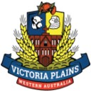

Kindly hosted by the Bolgart Sports Club and assisted by the Australian Government through the National Australia Day Council.

RSVP appreciated but not required please contact the Shire on 96287004.

